**The Potency Of Actinomycetes From Deepsea Sediment Of Makassar Strait For Producing Antimicrobial Substances**

**Ariani Hatmanti1, Puspita Lisdiyanti2, Jaka Widada3, and Subagus Wahyuono4**

1Research Center for Oceanography Indonesian Institute of Sciences,

Jl. Pasir Putih I Ancol Timur, Jakarta, Indonesia

2Research Center for Biotechnology Indonesian Instritute of Sciences,

Jl. Raya Bogor Km. 46, Cibinong Science Center, Cibinong 16911, West Java, Indonesia

3Faculty of Agriculture Gadjahmada University,

Bulaksumur, Yogyakarta, Indonesia

4Faculty of Pharmacy Gadjahmada University,

Bulaksumur, Yogyakarta, Indonesia

Corresponding author: email: ariehatmanti@gmail.com

**Abstract**

A research on antimicrobial screening of 36 actinomycetes isolated from marine sediment of Makassar Strait through Widya Nusantara Expedition (EWIN) in 2013 and 2014, enzymatic characterization of potential isolates, morphological characterization and metabolite profiling of selected isolates has been conducted. The antimicrobial screening was conducted using paper disc, enzymatic characterization was using APIZYM Kit, morphological characterization was using Scanning Electron Microscope. And metabolite profiling was using TLC and GCMS. Five isolates retrieved from this research had ability to inhibit the growth of the four microbial testing, *Escherichia coli*, *Bacillus subtilis*, *Staphyllococcus aureus* and *Candida albicans*, and the highest capability was shown by the MACMK-43 isolate that had 16S rRNA gene sequence similarity of 97.85% to *Streptomyces violacens*. The result showed that in GCMS, the active fraction was contained 4-amino-5-cyano-6-(4'methoxyphenyl)-1-methyl-2.3-dihydropyrrolo [2,3-B] pyridine which commercially used for bactericides and antihistamine.

**Keywords:** antimicrobes, actinomycetes, *Streptomyces violascens,* deepsea sediment

**1. Introduction**

Actinomycetes are a group of high G + C content Gram-positive bacteria, in which have an ability to produce diverse bioactive compounds, such as antibiotics, antifungals, antiparasites, and anticancer drugs (Mincer et al., 2002; Butler, 2004). Up to now of all the bioactive compounds produced by microbes, 45% were produced by actinomycetes and actinomycetes is still a major natural antimicrobial producer (Berdy, 2005; Hamaki et al., 2005).

The decline in the discovery of new substances obtained from terrestrial actinomycetes has led scientists and researchers to focus on exploring actinomycetes from extreme environments. Marine is one of the environments that began to be studied as a source on isolation of actinomycetes. The marine environment attracted the attention of researchers as a source of microbial isolation, and it has been reported that marine microbes including actinomycetes are useful for screening new secondary metabolites (Blunt et al., 2007; Lam, 2006; Khan et al., 2011).

Several studies have shown that actinomycetes isolated from the marine environment are metabolically active and have adapted to marine life (Bull et al., 2005; Lam, 2006; Valli et al., 2012). Marine actinomycetes are widely distributed in a variety of marine habitats from marine sand (Hong et al., 2008), mangrove sediments (Hong et al., 2009; Hong, 2013; Azman et al., 2015; Hamada et al., 2015a; Hamada et al., 2015b), seawater (Zhang et al., 2012), coastal sediments (Yu et al., 2015), and deep sea sediments (Pathom-aree et al., 2006; Bredholt et al., 2007 ; Luo et al., 2011; Zhang et al., 2015; Chen et al., 2016). The increasing number of studies on marine actinomycetes indicates that marine environment including the deep ocean, is a significant source for finding and discovering both the marine actinomycetes diversity and the secondary metabolites it produces (Skropeta and Wei, 2014; Xu et al., 2014). In the last few years several reports on the discovery of antimicrobial compounds of actinomycetes isolated from some deepsea are shown in Table 1. These potential strains were isolated from marine sediments in deepsea of South China Sea and Indian Ocean. This phenomenon was confirmed by Kamjam et al. (2017) that the deep ocean is a hot spot for hunting the source of marine origin actinomycetes and its new secondary metabolites, due to its uniqueness and extreme environment.

**Table 1**. Actinomycetes isolated from deepsea and its antimicrobial compounds

|  |  |  |  |
| --- | --- | --- | --- |
| Antimicrobes | Name of isolate | Source  (deepsea level in m) | Reference |
| Pseudono-cardians A-C | *Pseudonocardia* sp | South China Sea  (3,258 m) | Li et al., 2011 |
| Indole alkaloid | *Serinicoccus profundi* sp. nov. | Indian Ocean  (5,368 m) | Yang et al., 2013 |
| Lobophorins H dan I | *Streptomyces* sp. 12A35 | South China Sea  (2,134 m) | Pan et al., 2013 |
| Champacyclin | *Streptomyces* strain C42 | Baltic Sea  (241 m) | Pesic et al., 2013 |
| Abyssomycins J-L | *Verrucosispora* sp. | South China Sea  (2,733 m) | Wang et al., 2013 |
| D. sotamides B-D | *Streptomyces scopuliridis* | South China Sea  (3,536 m) | Song et al., 2014 |
| Bafilomycins B1 & C1 | *Streptomyces cavourensis* NA4 | South China Sea  (1.464 m) | Pan et al., 2015 |
| Dehydroxy-aquayamycins | *Streptomyces* sp. SCSIO 11594 | South China Sea  (2.403 m) | Song et al., 2015 |

During our study on isolation and identification of actinomycetes from deepsea sediments in the Makassar Strait with depths between 150 and 3,366 m, we obtained 36 actinomycetes. These strains were isolated mostly by Direct Dilution Method (33 strains or 91.67%); by Sodium Dodecyl Sulphate-Yeast Extract (SDS-YE) Method (5.56%, 2 isolates) and by Rehydration-Centrifugation Method (2.78%, 1 isolate) (Hatmanti et al., 2018). The media used for isolation were Actinomycetes Isolation Agar (AIA, Hymedia, India) and NBRC 802 media (Hamada et al., 2013). Molecular identification of the isolates was conducted using analysis of 16S rRNA gene sequencing. This study aims to conduct antimicrobial screening of the 36 isolates, then enzymatic characterization of potential isolates, and morphological characterization and metabolite profiling of selected isolate.

**2. Methods**

**2.1. Microbial strains**

Thirty-six marine actinomycetes strains used in this study are collections of Marine Microbiology Laboratory of the Oceanography Research Center LIPI, Ancol and Indonesian Culture Collections (InaCC) Biology Research Center LIPI. Bacterial testing used were *Escherichia coli*, *Bacillus subtilis,* and *Staphylococcus aureus,* while fungal testing usedwere *Candida albicans.* All isolation media were added with nalidixic acid and cycloheximide to hamper bacterial growth (Hayakawa et al., 1996).

**2.2. Fermentation and extraction of active substance**

Fermentation was carried out using medium of Starch Yeast Pepton Broth (SYP Broth), with a 10 gr soluble starch, 4 gr yeast extract, 2 gr pepton, in 1000 mL aquadest. Medium were sterilized with autoclave at 121°C, 2 atm pressure, for 15 minutes, then settled at room temperature and ready for use. One pure isolate was inoculated into the pre-culture medium containing 5 ml of SYP Broth medium, then incubated at 30°C for 2 days (48 hours) in the incubator shaker at 100 rpm. Thereafter the entire pre-cultured medium was transferred into a fermentation medium containing 100 mL of SYP Broth and incubated at 30°C in a shaker incubator at 100 rpm for 10 days (240 hours). The cultures were then extracted by adding approximately 1:1 = media:ethyl acetate. The flasks were shaked at 30oC and 100 rpm for 12 hours, then ethyl acetate fraction was transferred into new flask. Extract were evaporated using vacuum evaporator at temperature 30oC up to 10 ml. Raw material was then transferred into a vial, evaporated at room temperature to dry, 1 ml of methanol was added into each vial, and then dissolved and homogenized using vortex. The residual metabolite which was not soluble in methanol, was dissolved by 1 ml of DCM (Dichloromethan), and then homogenized using vortex. The extracts were stored at 4°C and ready to be screened.

**2.3. Antimicrobial Screening**

Antimicrobial screening was measured by paper disc method (Kanoh et al., 2008). Microbial testing used for screening were *E. coli, S. aureus, B. subtilis,* and *C. albicans*. *Escherischia coli, S. aereus,* and *B. subtilis* were grown on Nutrient Agar (NA) and Nutrient Broth (NB) medium, while *C. albicans* was grown on Potato Dextrose agar (PDA) medium or Potato Dextrose Broth (PDB) medium. Microbial testing were incubated at 37°C for 1 x 24 hours for *E. coli, S. aureus,* and *B. subtilis*, whereas at 2 x 24 hoursfor *C. albicans*. Petri dishes containing NA medium were smeared with each microbial testing of *E. coli, S. aureus,* and *B. subtilis*, while PDA medium was smeared with *C. albicans*. Applying was done aseptically on surface of medium by using a sterile cotton bud. A total of 15 μL of extract was dripped onto a 6 mm thick diameter paper disc, then dried in an aseptic laminar airflow. Each extract was dripped on each of 4 paper discs for 4 types of microbial testing. Each of the paper discs was then placed on agar medium that has been planted with microbial testing. The petri dishes were incubated, and observations were performed every 24 hours. Each emerging clear zone was measured and recorded as a constraint zone.

**2.4. Semi quantitatif enzymatic reaction**

The enzymatic reaction test was performed using APIZYM strip (Biomereux). The system consists of a strip with 20 microwells, the base of which contains the enzymatic substrate and its buffer. The enzymatic tests are inoculated with a dense suspension of organisms, which is used to rehydrate the enzymatic substrates. The metabolic and products produced during the incubation period are detected through colored reactions revealed by the addition of reagents.

Preparation was done by pouring about 5 ml of distilled aquades in an incubation box (a closed mica box) to create a moist atmosphere. The APIZYM kit strip was placed in the incubation box. Inoculation of actinomycetes culture into the strip was performed using a sterile micropipette. A total of 65 μl of liquid aktinomycetes cultures were introduced into each well. After inoculation, the incubation box was closed and incubated for 4-4.5 hours at 37°C. After incubation, the strip is then read by adding one drop of ZYM A reagent and one drop of ZYM B reagent to each well, left to about 5 minutes, then the color formed and observed according to manufacture manual.

**2.5. Fractionation, purification and determination of active compounds**

The fractionation of the active compound was carried out using silica gel chromatography column and solvent selection for chromatography was used Thin Layer Chromatography (TLC), while the characterization of the active compound was performed by using Gas Chromatography Mass Spectrophotometer (GCMS).

**2.6. Scanning Electron Microscopy**

Morphological performance of MACMK-43 strain was observed by JEOL JSM 5310 LV Scanning Electron Microscopy (SEM).

**3. Results and Discussion**

**3.1. Capability of deepsea actinomycetes on producing antimicrobial compounds**

Thirty-six isolates of actomycetes have been isolated from the Makassar Strait seafloor sediments with depths on between 150 and 3,366 meters. Those were divided into 9 genera including *Micromonospora, Verrucosispora, Streptomyces, Luteipulveratus, Nocardiopsis, Micrococcus, Gordonia, Kytococcus,* and *Arthrobacter* (Hatmanti et al., 2018). The 36 isolates have been tested for inhibition of 3 bacterial testing and 1 fungus testing, ie, *E. coli, S. aureus, B. subtilis* and *C. albicans*, and obtained the results as shown in Table 2. From 36 strains, 14 strains inhibited the growth of *E. coli*, 5 strains inhibited *S. aureus* and *B. subtilis*, and 27 strains inhibited *C. albicans*. Based on Table 2, five best isolates were selected which were capable of inhibiting all four types of pathogens and had greatly inhibitory power by showing larger clear zones than other. The strains were MACMK-14 (*Micrococcus yunnanensis* 99.78%), MACMK-37 (*Micromonospora chalcea*, 99.64%), MACMK-43 (*Streptomyces violascens*, 97.58%), MACMK-72 (*Verrucosispora gifhornensis*, 99.85%), and MACMK-80 (*Kytococcus sedentarius*, 99.78%). Figure 1 showed clear zone produced by five leading strains inhibiting *C. albicans*, compared to others. The clear zone indicates that actinomycetes strains retrieved from marine sediments of Makassar Strait are able to inhibit the growth of *C. albicans*. MACMK-43 strain was selected for further analysis.

**Table 2**. Results of antimicrobial assay of 36 strains of actinomycetes from deepsea sediment of Makassar Strait against microbial testing *E. coli, B. subtilis, S. aureus,* and *C. albicans* by paper disc methods

|  |  |  |  |  |  |  |  |  |
| --- | --- | --- | --- | --- | --- | --- | --- | --- |
| No | Strains code | Top Hit Taxon | Top Hit Strain | Identity  (%) | Diameter (mm) | | | |
| *E. coli* | *S. aureus* | *B. subtilis* | *C. albicans* |
| 1 | MACMK-08 | *Micromonospora chalcea* | DSM 43026T | 99.71 | - | - | - | 8 |
| 2 | MACMK-09 | *Gordonia didemni* | B204T | 98.52 | - | - | - | 7.5 |
| **3** | **MACMK-14\*** | ***Micrococcus yunnanensis*** | **YIM 65004T** | **99.78** | **26.33** | **1.2** | **0.78** | **26.6** |
| 4 | MACMK-19 | *Micromonospora tulbaghiae* | DSM 45142T | 99.18 | - | - | - | 8 |
| 5 | MACMK-20 | *Nocardiopsis alba* | DSM 43377T | 99.93 | - | - | - | **-** |
| 6 | MACMK-25 | *Micromonospora tulbaghiae* | DSM 45142 T | 98.52 | 9.7 | - | - | 11.1 |
| 7 | MACMK-32 | *Micromonospora auratinigra* | DSM 44815 T | 98.83 | - | - | - | 11 |
| **8** | **MACMK-37\*** | ***Micromonospora chalcea*** | **DSM 43026** T | **99.64** | **19.9** | **1** | **0.7** | **22.3** |
| **9** | **MACMK-43\*** | ***Streptomyces violascens*** | **ISP 5183** T | **97.58** | **21.13** | **1.2** | **0.7** | **28.95** |
| 10 | MACMK-52 | *Micromonospora tulbaghiae* | DSM 45142 T | 99.27 | 1.19 | - | - |  |
| 11 | MACMK-53 | *Micromonospora tulbaghiae* | DSM 45142 T | 99.35 | 0.88 | - | - | 10.7 |
| 12 | MACMK-54 | *Micromonospora tulbaghiae* | DSM 45142 T | 94.73 | 1.7 | - | - | 7.3 |
| 13 | MACMK-55P | *Micromonospora tulbaghiae* | DSM 45142 T | 99.42 | 8.2 | - | - | - |
| 14 | MACMK-55C | *Micromonospora chalcea* | DSM 43026 T | 99.64 | - | - | - | - |
| 15 | MACMK-56 | *Streptomyces diastaticus* subsp*. Diastaticus* | NBRC 3714 T | 98.92 | - | - | - | 10.2 |
| 16 | MACMK-57 | *Arthrobacter subterraneus* | CH7 T | 99.77 | 10.8 | - | - | 8.9 |
| 17 | MACMK-58 | *Streptomyces diastaticus* subsp*. Ardesiacus* | NRRL B-1773 T | 99.64 | - | - | - | 8.2 |
| 18 | MACMK-60 | *Verrucosispora gifhornensis* | DSM 44337 T | 99.18 | 18.6 | - | - | - |
| 19 | MACMK-61 | *Micromonospora wenchangensis* | CCTCC AA 2012002 T | 100.00 | - | - | - | 1 |
| 20 | MACMK-62 | *Micromonospora tulbaghiae* | DSM 45142 T | 99.48 | - | - | - | - |
| 21 | MACMK-63 | *Micromonospora tulbaghiae* | DSM 45142 T | 100.00 | - | - | - | 8 |
| 22 | MACMK-64 | *Micromonospora maritime* | D10-9-5 T | 99.85 | - | - | - | 7.9 |
| 23 | MACMK-65 | *Verrucosispora fiedleri* | MG-37 T | 99.56 | - | - | - | 10.3 |
| 24 | MACMK-66 | *Micromonospora chalcea* | DSM 43026 T | 99.71 | - | - | - | - |
| 25 | MACMK-67 | *Micromonospora chalcea* | DSM 43026 T | 99.71 | - | - | - | 7 |
| 26 | MACMK-68 | *Micromonospora tulbaghiae* | DSM 45142 T | 99.35 | - | - | - | 8.6 |
| 27 | MACMK-69 | *Micromonospora tulbaghiae* | DSM 45142 T | 99.11 | - | - | - | 9.6 |
| 28 | MACMK-70 | *Luteipulveratus halotolerans* | C296001 T | 99.93 | 10.9 | - | - | 9.4 |
| 29 | MACMK-71 | *Verrucosispora gifhornensis* | DSM 44337 T | 99.71 | 9.3 | - | - | 7.5 |
| **30** | **MACMK-72\*** | ***Verrucosispora gifhornensis*** | **DSM 44337** T | **99.85** | **21.8** | **1.05** | **0.8** | **28.9** |
| 31 | MACMK-73 | *Micromonospora tulbaghiae* | DSM 45142 T | 99.49 | - | - | - | 0.65 |
| 32 | MACMK-74 | *Verrucosispora gifhornensis* | DSM 44337 T | 99.86 | - | - | - | 7.7 |
| 33 | MACMK-75 | *Luteipulveratus halotolerans* | C296001 T | 100.00 | - | - | - | - |
| 34 | MACMK-77 | *Micromonospora terminaliae* | TMS7 T | 99.26 | - | - | - | 9.6 |
| **35** | **MACMK-80\*** | ***Kytococcus sedentarius*** | **DSM 20547** T | **99.78** | **17.9** | **0.95** | **0.7** | **21.9** |
| 36 | MACMK-81 | *Micromonospora maritime* | D10-9-5 T | 100.00 | - | - | - | - |

* Bold are the best five of actinomycetes strains



A

B

A

A

A

A

B

B

B

B

**MACMK-14 MACMK-37 MACMK-43**



**MACMK-72 MACMK-80**

Figure 1. Clear zone showed by isolate MAMCK-14, MACMK-37, MACMK-43, MACMK-72 dan MACMK-80 against microbial testing *C. albicans*, A: raw extract in methanol, B: raw extract in DCM

**3.2. The enzymatic activity of five actinomycetes producing active compound**

The enzymatic activity of the five selected strains was tested using APIZYM (Biomereux). The photographs of the test results are shown in Figure 2 and the test readings are listed in Table 3. Quantitative readings showed that MACMK-43 strains have stronger and more diverse enzymatic activity against some substrates than others. MACMK-80 strains have very weak enzymatic activity compared to others. It was showed by small value of hydrolyzed substrate quantity on APIZYM strips of isolate 80 in Figure 2 and the quantitative data can be seen in Table 3.

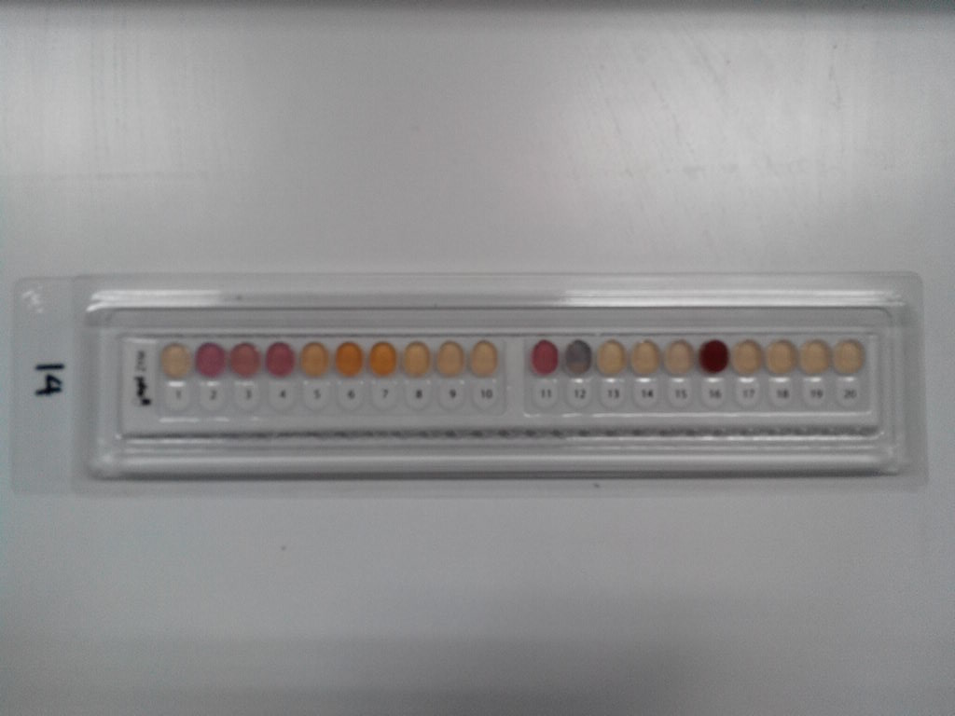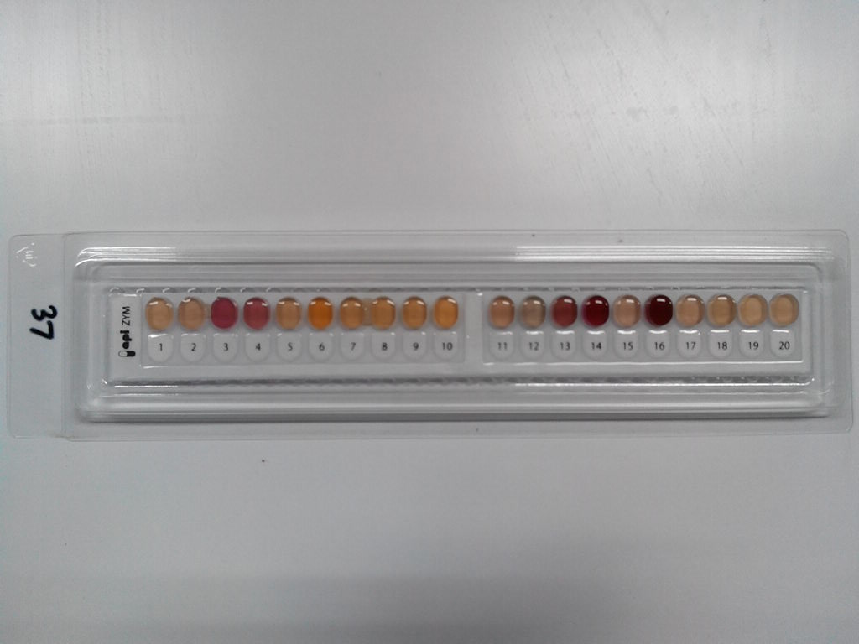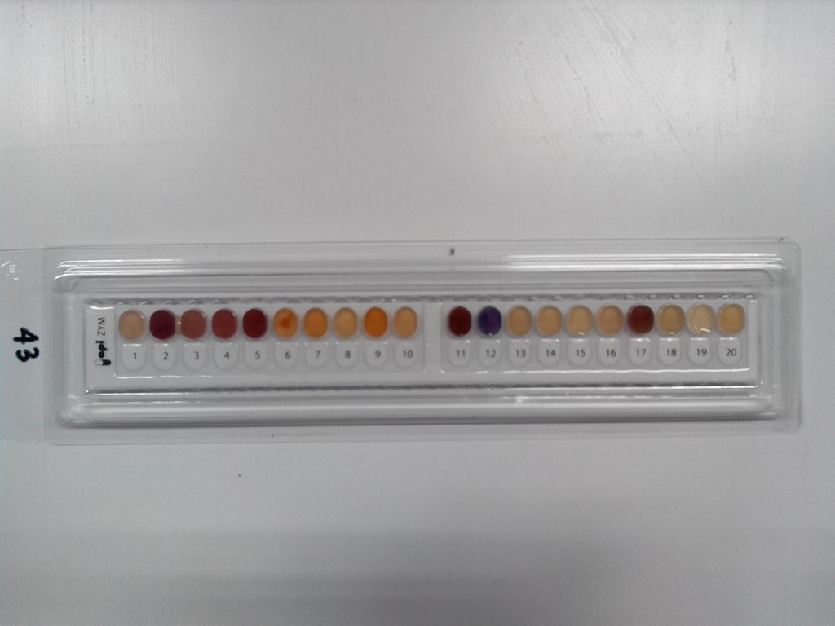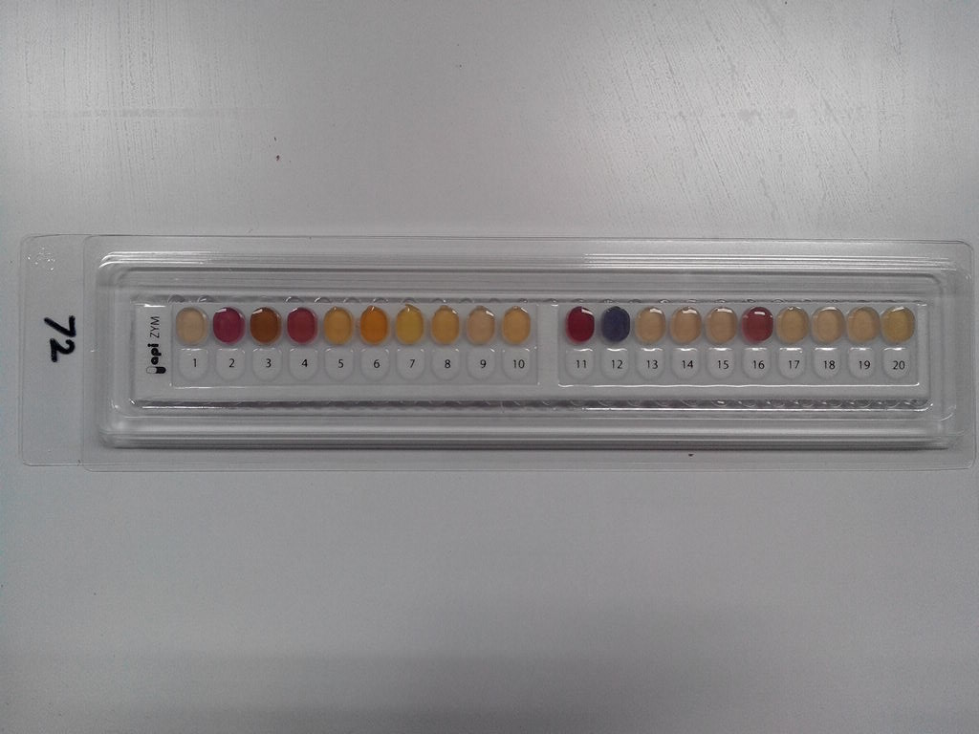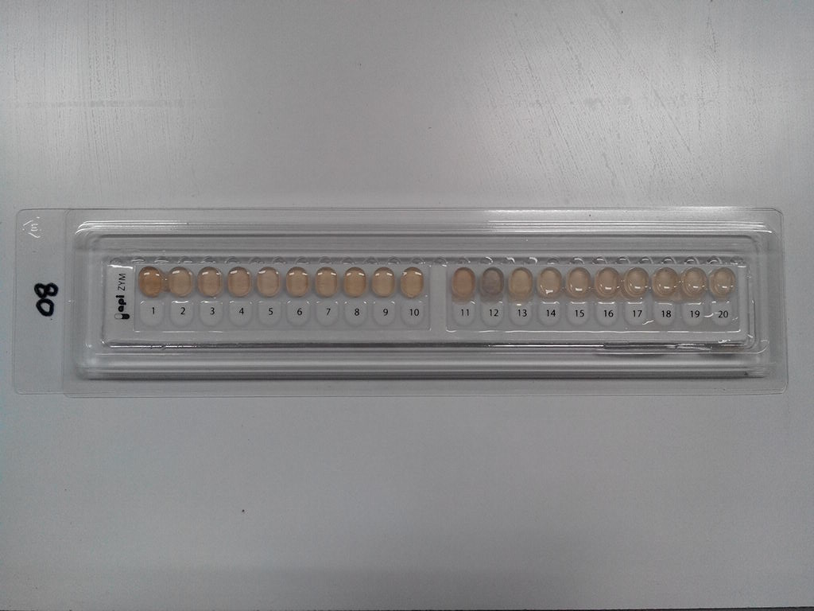

**Figure 3**. Enzymatic test of 5 isolates the pre-eminent using strip APIZYM (Biomereux)

The MACMK-43 strain showed positive reaction to the following enzymatic activity: alkaline phosphatase, esterase lipase, lipase, leucine arylamidase, valine arylamidase, trypsin, acid phosphatase, Naphthol-AS-BI-phosphohydrolase, β-glucosidase, esterase and N-acetyl-β-glucosaminidase, cystine arylamidase, α-chymotrypsin, but no enzymatic activity against α-galactosidase, β-galactosidase, β-glucuronidase, and α-glucosidase. Nearly all substrates that could be degraded by MACMK-43 show a large quantity of> 40 nanomoles. This suggests that this strain has a high enzymatic potential that can be developed.

**Table 3.** Results of enzymatic reaction of the best 5 isolates were used APIZYM

|  |  |  |  |  |  |  |
| --- | --- | --- | --- | --- | --- | --- |
| No | Enzyme | Isolate Code | | | | |
| MACMK-14 | MACMK-37 | MACMK-43 | MACMK-72 | MACMK-80 |
| 1 | Control | 0 | 0 | 0 | 0 | 0 |
| 2 | Alkaline phosphatase | 3 | 1 | 5 | 5 | 1 |
| 3 | Esterase (C4) | 3 | 5 | 3 | 5 | 1 |
| 4 | Esterase Lipase (C8) | 3 | 3 | 5 | 5 | 1 |
| 5 | Lipase (C14) | 1 | 1 | 5 | 1 | 0 |
| 6 | Leucine arylamidase | 5 | 3 | 5 | 3 | 0 |
| 7 | Valine arylamidase | 3 | 1 | 5 | 1 | 0 |
| 8 | Cystine arylamidase | 0 | 1 | 1 | 1 | 0 |
| 9 | Trypsin | 0 | 1 | 5 | 1 | 0 |
| 10 | -chymotrypsin | 0 | 1 | 1 | 1 | 0 |
| 11 | Acid pshosphatase | 3 | 1 | 5 | 5 | 1 |
| 12 | Naphthol-AS-BI-phosphohydrolase | 3 | 1 | 5 | 5 | 1 |
| 13 | -galactosidase | 0 | 5 | 0 | 0 | 0 |
| 14 | -galactosidase | 0 | 5 | 0 | 0 | 0 |
| 15 | -glucuronidase | 0 | 0 | 0 | 0 | 0 |
| 16 | -glucosidase | 5 | 5 | 0 | 5 | 1 |
| 17 | -glucosidase | 0 | 0 | 5 | 0 | 0 |
| 18 | N-acetyl--glucosaminidase | 0 | 3 | 3 | 0 | 0 |
| 19 | -mannosidase | 0 | 0 | 0 | 0 | 0 |
| 20 | -fucosidase | 0 | 0 | 0 | 0 | 0 |

**3.3. Isolation and purification of active compounds from MACMK-43 strain**

Hexane and ethyl acetate were used for fractionation of active compound extracts produced by MACMK-43. The selection of the solvent was based on the TLC results indicating that the crude extract separately separated using hexane : ethyl acetate compared to methanol : ethyl acetate (Figure 3).

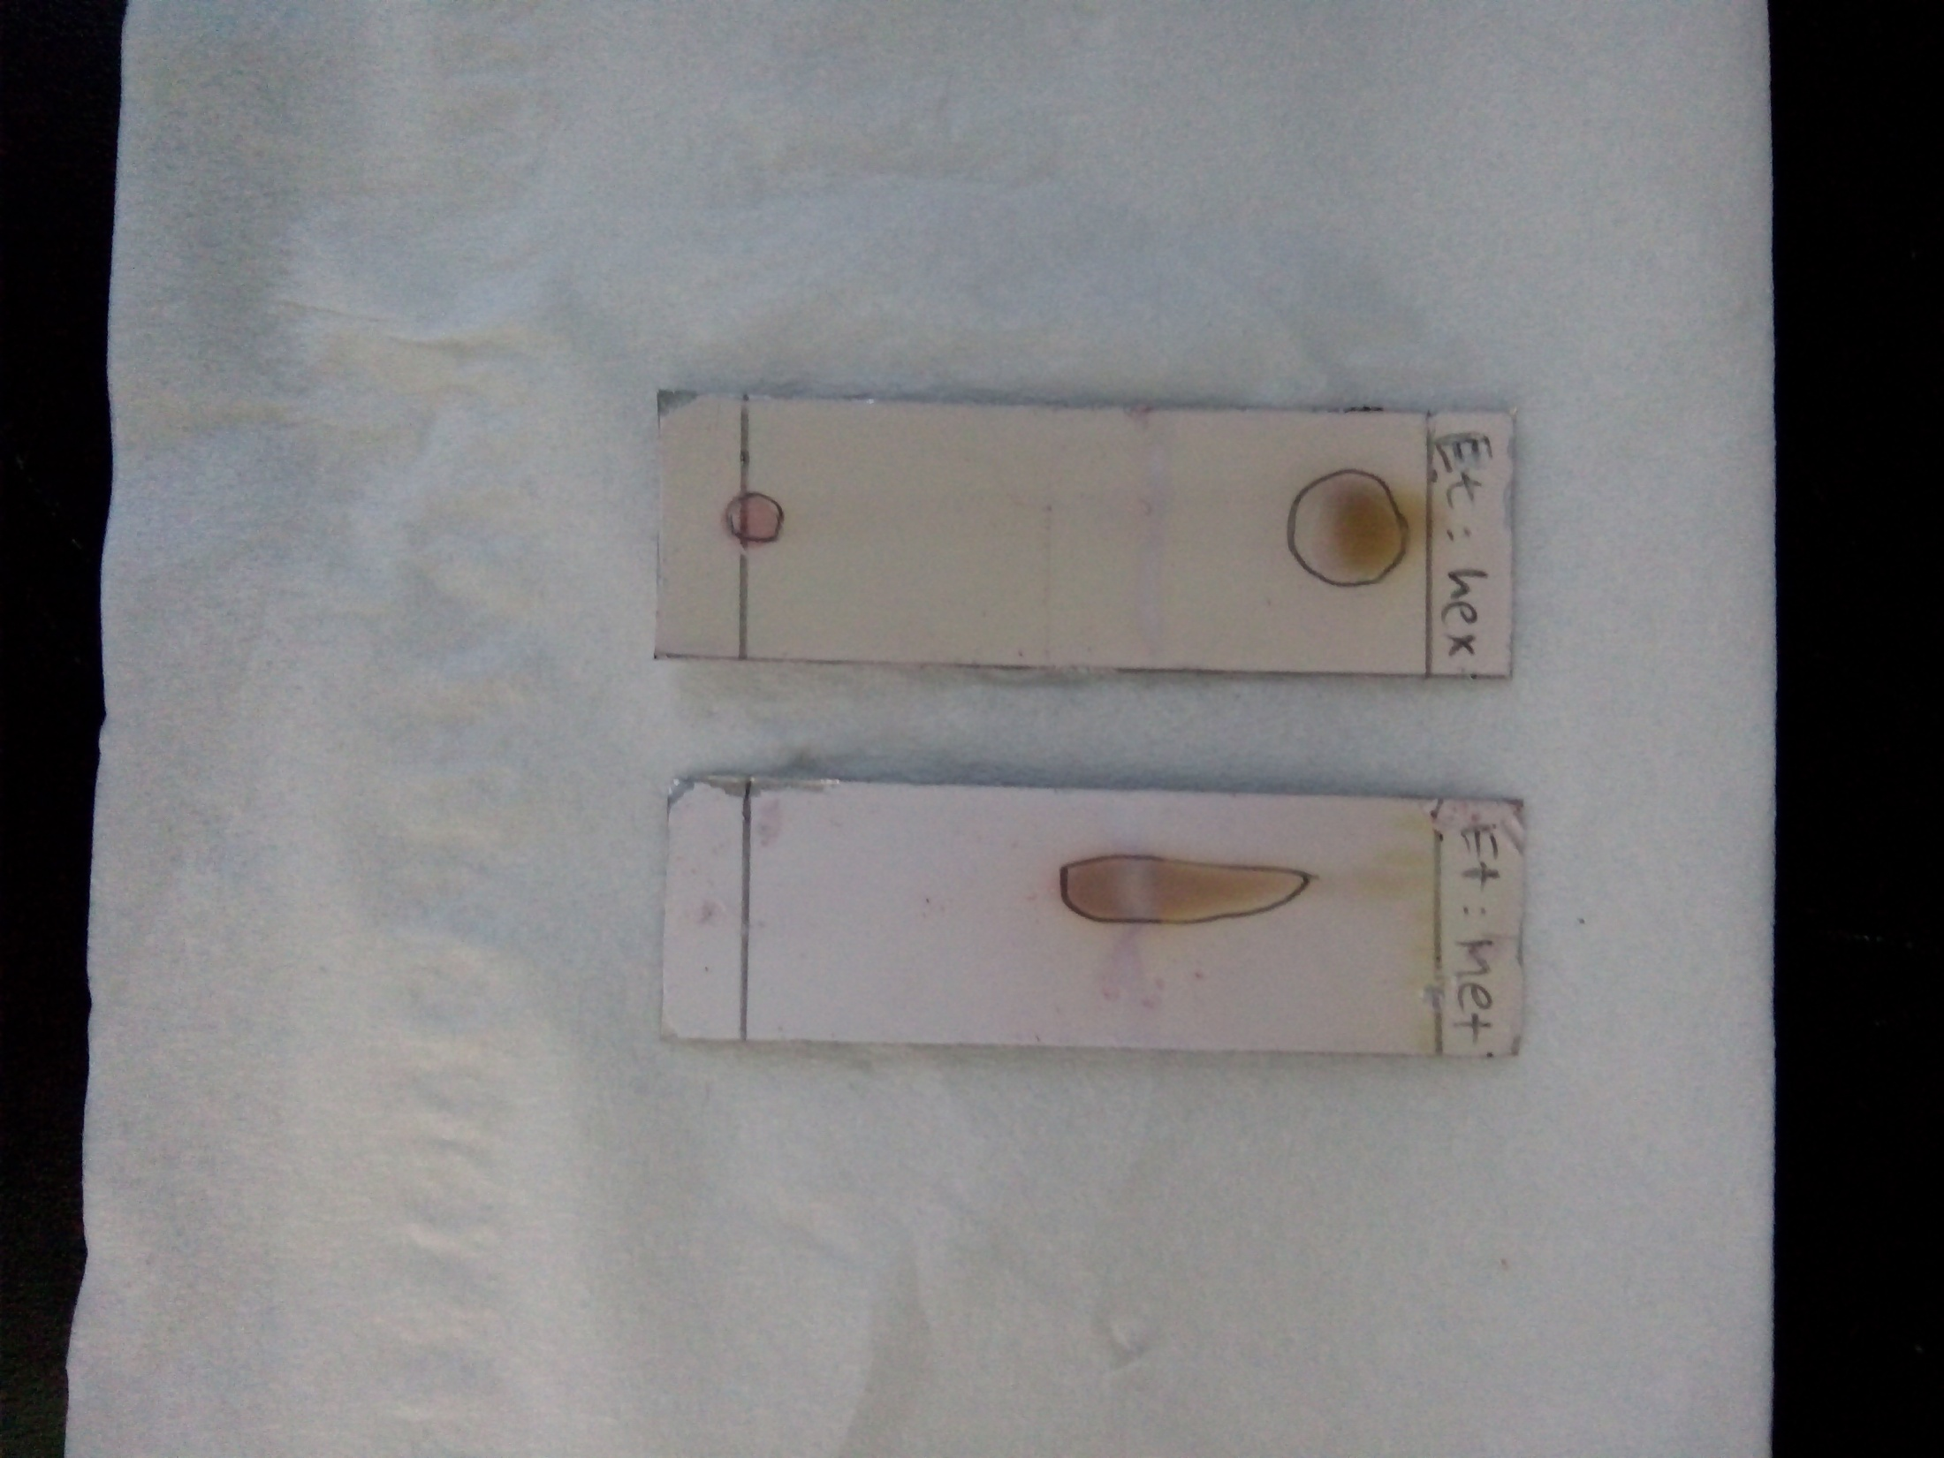

**A B**

**Figure 3.** Performance of TLC for raw extract produced by MACMK-43 by several solvents. A (hexane : ethyl acetate); B (methanol : ethyl acetate)

Fractionation of the ethyl acetate fraction of the MACMK-43 strain was performed by chromatographic columns and yielded as many as 26 fractions. The 26 fractions were tested for resistance against *C. albicans*, and found that the most active compound was showed in the 2nd fraction (Figure 4). The active compound of the 2nd fraction (Figure 4B) strongly inhibits the growth of *C. albicans* compared to before purification (Figure 4A). This indicates that the active compound has potential as antimicrobial, especially antifungi against *C. albicans*.



A. Before fractination B. After fraksination, Fraction-2

**Figure 4**. Clear zona of 2nd fraction of secondary metabolite produced by MACMK-43 strain

The result of GCMS examination, compared to the library database in the tool, shows that the 2nd fraction of active metabolite contain 13 compounds (Table 4). The compounds include Benzenemethanol, ar-ethyl; 2-pyridinecarbonitrile, 3-ethyl-1,2,5,6-tetrahydro-1methyl; 1H-indole, 2,3-dihydro-1,2-dimethyl; 2,4,6-trimethylbenzyl alcohol; Benzene, 1-ethenyl-4-methyl; 4-methyl-1-indonone; Phenol, nonyl; Nonyl-phenol mix of isomers; 7.9-di-tert-butyl-1-oxaspiro [4.5] deca-6,9-diene-2,8-dione; Dibutyl phthalate; 1-methyl [2,2] paracyclophan-1-en; 4-amino-5-cyano-6- (4'methoxyphenyl) -1-methyl-2,3-dihydropyrrolo [2,3-B] pyridine. Compounds with the largest content of 59.67% and quality 90% is the highest peak, with retention time (RT) of 31.885 minutes (13th compound). The compound is thought to be 4-amino-5-cyano-6- (4'methoxyphenyl) -1-methyl-2,3-dihydropyr rolo [2,3-B] pyridine.

**Table 4**. Metabolite profiling of 2nd fraction of secondary metabolite produced by MACMK-43 strain analysis by GCMS.

|  |  |  |  |  |
| --- | --- | --- | --- | --- |
| No | RT | Quality | Compound | Percentage (%) |
| 1 | 10.241 | 38 | Benzenemethanol, ar-ethyl | 1.08 |
| 2 | 11.344 | 64 | 2-pyridinecarbonitril, 3-ethyl-1,2,5,6-tetrahydro-1methyl | 1.47 |
| 3 | 13.447 | 55 | 1H-indole, 2,3-dihydro-1,2-dimethyl | 6.44 |
| 4 | 14.723 | 96 | 2,4,6-trimethylbenzyl alcohol | 3.38 |
| 5 | 15.178 | 93 | Benzene, 1-ethenyl-4-methyl | 1.2 |
| 6 | 15.881 | 60 | 4-methyl-1-indonone | 2.79 |
| 7 | 26.5 | 97 | Phenol, nonyl | 2.94 |
| 8 | 26.907 | 87 | Phenol, nonyl | 2.59 |
| 9 | 26.982 | 93 | Nonyl-phenol mix of isomers | 1.57 |
| 10 | 28.506 | 99 | 7,9-di-tert-butyl-1-oxaspiro[4.5]deca-6,9-diene-2,8-dione | 7.25 |
| 11 | 28.665 | 72 | Dibutyl phthalate | 2.67 |
| 12 | 29.079 | 99 | 1-methyl[2,2]paracyclophan-1-en | 1.59 |
| 13 | 31.885 | 90 | 4-amino-5-cyano-6-(4'methoxyphenyl)-1-methyl-2,3-dihydropyrrolo[2,3-B]pyridine | 59.67 |

Althaf et al. (2015) has reported various pyridine derivatives of compounds 3 to 28 have varying abilities. Althaf et al. (2015) states that pyridine derivatives such as acyl hydrazine (compound 3) and acyl hydrazine (arylsulfonyl) (compound 4) have antibacterial activity against Gram-negative *E. coli* and Gram-positive bacterium *S. albus* compared to streptomycine sulfate standard, also was tested as herbicides against *Cynodon dactylone, Cyperus rotundus, Echinochola crusgalli, Euphorbia hirta, Celocia argentia, Eugenia indica* and *Tridax procumbens*. Pyridine has also attempted its ability as an antifungal agent against *Aspergillus niger* and *Aspergillus teniussiama* by using Griseofulvin as standard (Chavan et al., 2006). Type 5 compounds comprising hydrophelic and lipophilic parts also have antimicrobial ability Savchenko et al. (2010). Similarly Thienopyridine and other pyridine-derived compounds of type 6-14 have antibacterial activity against Gram-positive *S. aureus* and efficiently against Gram-negative *E. coli, Pseudomonas aeruginosa* and *Pseudomonas vulgaris* (Zav'yalova et al., 2009).

Naik and Chikhalia (2007) reported that a series of pyrimidin derivatives such as compounds of types 15 and 16 showed antimicrobial activity and the maximum zone of inhibition had been observed against *E. coli*, *S. aureus, Salmonella typhi* and *B. subtitlis.* Type 17 compounds have also been tested showing activity against *E. coli*. Compound 18 shows the efficiency inhibiting *S. aureus*, while compounds 19 and 20 are active against *S. typhi*. Type 20 compounds exhibit activity against *B. subtilis* compared with standard drugs.

The 3-hydroxypyridine-4-ones and 3-hydroxy-pyran-4-ones compounds contain pyridine ring, reportedly active against *S. aureus, A. niger* and *C. albicans* (Sabet et al., 2009). Althaf et al. (2015) states that the type of 3-substituted methylene-2H-thiopyrano pyridin-4 (3H) -ones [2,3-b] compound was tested as an antifungal in vitro, and it was concluded that all compounds had the ability to be antifungal. Compound 21 showed activity comparable to Fluconazole to *Microsporum gypseum, Candida krusei,* and *Candida glabrata*. Al-Salahi et al. (2010) reported that compounds 22-27 had antimicrobial activity almost proportional to the Ketaconazole drug reference. Compounds of 24-28 species observed for their antibacterial activity have similar rates for the frequently-used drug Ciprofloxacin.

Pyridine and its derivatives have antimicrobial (antibacterial and antifungal), antiviral, antioxidant, antidiabetic, anticancer, antimalarial, antihistamine, anti-inflammatory, antiamoeba, and enzyme inhibitory properties (Althaf et al., 2015). Therefore, this study still has the potential to be developed so that the ability of MACMK-43 which has similarity of 97,85% with *S. violascens* can be further observed its ability to produce secondary metabolite.

**3.4. The MACMK-43 profile on SEM JSM 5310 LV**

The profile of MACMK-43 strain under Scanning Electron Microscopy TYPE JSM-5000 with MAG X10,000 condition; ACCV 20kV; WIDTH 13.2um is shown in Figure 5. The isolate has the morphology typical to the genus *Streptomyces* with the spores and mycelium.

D:\BUNDA\Doktoral\DATA SIAP SAJI\SEM\43\FIS018.TIF

Figure 5. Photo Scanning Electronic Microscopy (SEM) strain MACMK-43

**4. Conclusion**

This research has conclude that from the deepsea sediments of Makassar Strait (150 – 3,366 meters) had been isolated 36 strains of actinomycetes, which some of them produce antimicrobial active compounds. Fourteen strains inhibited the growth of *E. coli*, 5 strains inhibited Gram positive *S. aureus* and *B. subtilis*, and 27 strains inhibited *C. albicans*. The best strain were MACMK-43 which has 97.85% 16S rRNA gene sequence similarity with *S. violascens*. It produced secondary metabolite which the active fraction was contained 4-amino-5-cyano-6-(4'methoxyphenyl)-1-methyl-2.3-dihydropyrrolo [2,3-B] pyridine which commercially used for bactericides and antihistamine.

**5. Acknowledments**

The authors would like to thank the Director of Research Center Oceanography LIPI which has given the author the opportunity to participate in the expedition of Widya Nusantara 2013, Research Center for Biotechnology LIPI for conducting research and Research Center for Biology LIPI, especially Indonesian Culture Collection (InaCC) where this research was conducted. This research was funded by DIPA 2013 LIPI and LIPI Priority Program, SubProgram Food and Drug Resilience 2016.

The author also thanks Dr. Shanti Ratnakomala, Dr. Tutik Murniasih, and Dinihari Indah Kusumawardani who participated in the research activities undertaken.

**6. References**

Al-Salahi, R. A., Al-Omar, M. A., Amr, A. E. G. E. (2010). Synthesis of chiral macrocyclic or linear pyridine carboxamides from pyridine-2, 6-dicarbonyl dichloride as antimicrobial agents. *Molecules*, *15*(9), 6588-6597.

Altaf, A. A., Shahzad, A., Gul, Z., Rasool, N., Badshah, A., Lal, B., Khan, E. (2015). A review on the medicinal importance of pyridine derivatives. *Journal of Drug Design and medicinal chemistry*, *1*(1), 1-11.

Azman, A. S., Othman, I., Velu, S. S., Cha, K. G., Lee, L. H. (2015). Mangrove rare actinobacteria: taxonomy, natural compound, and discovery of bioactivity. *Front Microbiology,* 6, 856. doi: 10.3389/fmicb.00856.

Berdy, J. (2005). Bioactive microbial metabolites.*Jurnal Antibiotics,* *58*, 1-26.

Bredholdt, H., Olga, A. G., Kerstin, E., Espen, F., Larissa, P. T., Sergey, B. Z. (2007). Rare actinomycete bacteria from shallow water sediments of the Trondheim fjord, Norway: isolation, diversity and biological activity. *Environmental Microbiology,* 9(11), 2756-2764.

Blunt, J. W., Copp, B. R., Hu W. P., Munro, M. H., Northcote, P. T, Prinsep, M. R. (2007). Marine Natural Product. *Natural. Product. Reports., 24*, 31-86.

Bull, A. T., Stach, J. E. M., Ward, A. C., Goodfellow, M. (2005). Marine actinobacteria: perspectives, challenges, future directions. *Antonie Van Leeuwenhoek,* 87, 65-79.

Butler, M. S. (2004). The role of natural product chemistry in drug discovery. *Journal of Natural Product*, *67*, 2141–2215.

Chavan, V. P., Sonawane, S. A., Shingare, M. S., & Karale, B. K. (2006). Synthesis, characterization, and biological activities of some 3, 5, 6-trichloropyridine derivatives. *Chemistry of Heterocyclic Compounds*, *42*(5), 625-630.

Chen, P., Zhang, L., Guo, X., Dai, X., Liu, L., Xi, L., Wang, J., Song, L., Wang, Y., Zhu, Y., Huang, L., Huang, Y. (2016). Diversity, biogeografi, and biodegradation potential of actinobacteria in the deepsea sediment along the Southwest Indian Ridge. *Frontier Microbiology, 7*, 1340. doi :10.3389/fmicb.2016.01340.

Hamada, M., Shibata, C., Tamura, T., Suzuki, K. (2013). *Zhihengliuella flava sp. nov.,* an actinobacterium isolated from sea sediment, and emended description of the genus *Zhihengliuella. International Journal of Systematics and Evolutionary of Microbiology,* *63*, 4760-4764.

Hamada, M., Chiyo, S., Nurkanto, A., Ratnakomala, S., Lisdiyanti, P., Tomohiko, T., Ken-ichiro, S. (2015a). *Tropicihabitans flavus* gen. nov., sp. nov., a new member of the family *Cellulomonadaceae. Antonie van Leeuwenhoek,* 107, 1299-1306.

Hamada, M., Chiyo, S., Nurkanto, A., Ratnakomala, S., Lisdiyanti, P., Tomohiko, T., & Ken-ichiro, S. (2015b). *Serinibacter tropicus* sp. nov., an actinobacterium isolated from the rhizosphere of a mangrove, and emended description of the genus *Serinibacter*. *International Journal of Systematics and Evolutionary of Microbiology,* 65, 1151-1154.

Hamaki, T., Suzuki, M., Fudou, R., Jojima, Y., Kajiura, T., Tabuchi, A. (2005). Isolation of novel bacteria and actinomycetes using soil-extract agar medium. *Journal of Bioscience and Bioengineering,* *99*, 485–492.

Hatmanti, A., Lisdiyanti, P., Widada, J., & Wahyuono, S. 2018. Diversity Of Culturable Actinomycetes From Deepsea Floor of Makassar Strait, Indonesia. Oseanologi dan Limnologi di Indonesia, Pusat Penelitian Oseanografi LIPI. (accepted)

## Hayakawa, M., Momose, Y., Yamazaki, T., & Nonomura, H., 1996. A method for the selective isolation of *Microtetraspora glauca* and related four‐spored actinomycetes from soil. *Applied Microbiology 80(4):375-386.* <https://doi.org/10.1111/j.1365-2672.1996.tb03232.x>

Hong, K. (2013). Actinomycetes from mangrove and their secondary metabolites. *Acta Microbiology Sinica, 53*, 1131-1141.

Hong, K., Gao, A. H., Xie, Q., Gao, H., Zhuang, L., Lin, H. P., Yu, H. P., Li, J., Yao, X. S., Goodfellow, M., Ruan, J. S. (2009). Actinomycetes for marine drug discovery isolated from mangrove soils and plants in China. *Marine Drugs, 7*, 24-44. doi : 10.3390/md7010024.

Hong, S. G., Lee, Y. K., Yim, J. H., Chun, J., Lee, H. K. (2008). *Sanguibacter antarticus* sp nov., isolated from Antarctic sea sand. *International Journal of Systematics and Evolutionary of Microbiology, 58*, 50-52. doi : 10.1099/ijs.0.60531-0

Kamjam, M., Sivalingam, P., Deng, Z., & Hong, K. (2017). Deepsea actinomycetes and their secondary metabolites. *Frontiers in Microbiology,* 8, 760. doi: 10.3389/fmicb.2017.00760

Kanoh, K., Adachi, K., Katsuta, A., & Shizuri, Y. (2008). Structural Determination and Proposed Biosynthesis of Alcanivorone, a Novel α-Pyrone Produced by *Alcanivorax jadensis*. *The Journal of antibiotics*, *61*(2), 70.

Khan, S. T., Komaki, H., Motohashi, H., Kozone, I., Takagi, M., & Kazuo, S. (2011). *Streptomyces* associated with marine sponge *Haliclona* sp.: biosynthetic genes for secondary metabolites and products. *Environments Microbiology, 13*, 391-403.

Lam, K. S. (2006). Discovery of novel metabolites from marine actinomycetes. *Curr. Opin Microbiol,* 9:245-251.

Li, S., Tian, X., Niu, S., Zhang, W., Chen, Y., & Zhang, H. (2011). Pseudonocardians AC, new Diazanthraquinone derivates from a deep sea actinomycete *Pseudonocardia* sp. SCSIO 01299. *Marine Drugs, 9*, 1428-1439. doi : 10.3390/md9081428

Luo, Y., Jing, X., Yin, W., Jing, X., Shujie, X., & Jun, X. (2011). *Streptomyces indicus* sp nov., an actinomycete isolated from deep-sea sediment. *International Journal of Systematics and Evolutionary of Microbiology,* 61, 2712-2716.

Mincer, T. J., Paul, R .J., Christopher, A. K., & William, F. (2002). Widespread and persistent population of a major new marine actinomycete taxon in ocean sediments. *Applied and Environment Microbiology, 68*, 5005-5011.

Naik, T. A. & Chikhalia, K. H. (2007). Studies on synthesis of pyrimidine derivatives and their pharmacological evaluation. *Journal of Chemistry*, *4*(1), 60-66.

Pan, H. Q., Yu, S. Y., Song, C. F., Wang, N., Hua, H. M., Hu, J. C., & Wang, S.J. (2015). Identification and characterization of the antifungal substances of a novel *Streptomyces cavourensis* NA4. *Jurnal of. Industrial. Microbiology and. Biotechnology,* 25, 353-357. doi : 10.4014/jmb.1407.07025.

Pan, H. Q., Zhang, S. Y., Wang., N., Li, Z. I., Hua, H. M., Hu, J. C., Wang, S.J. (2013). New spirotetronate antibiotics Iobophorins H and I from a South China sea derived *Streptomyces* sp. 12A35. *Marine Drugs 11*, 3891-3901. doi : 10.3390/md11103891

Pathom-aree, W., James, E. M., Stach, A. C. W., Koki, H.,, Bull, A. T., Goodfellow, M. (2006). Diversity of actinomycetes isolated from Challenger Deep sediment (10,898 m) from Mariana Trench. *Extremophiles, 10*, 181-189.

Pesic, A., Baumann, H. I., Kleinschmidt, K., Ensle, P., Wiese, J., Süssmuth, R. D., & Imhoff, J. F. (2013). Champacyclin, a new cyclic octapeptide from Streptomyces strain C42 isolated from the Baltic Sea. *Marine drugs*, *11*(12), 4834-4857.

Sabet, R., Fassihi, A., Moeinifard, B. (2009). Preliminary MLR studies of antimicrobial activity of some 3-hydroxypyridine-4-one and 3-hydroxypyran-4-one derivatives. *Research in Pharmaceutical Sciences*, *2*(2), 103-112.

Savchenko, V. I., Dorokhov, V. G., Yakushchenko, I. K., Zyuzin, I. N., & Aldoshin, S. M. (2010). Developing state-of-the-art antiseptics based on pyridine derivatives. *Herald of the Russian Academy of Sciences*, *80*(2), 149-154.

Skropeta, D., Wei, L. (2014). Recent advances in deepsea natural product. *Natural Product Reports, 31*, 999-1025. doi: 10.1039/C3NP70118B.

Song, Y., Li, Q., Liu, X., Chen, Y., Zhang, Y., Sun, A., Zhang, W., Zhang, J., & Ju, J. (2014). Cyclic hexapeptides from the deep South China sea derived *Streptomyces scopuliridis* SCSIO ZJ46 active against pathogenic gram positive bacteria. *Journal of Natural Product, 77*, 1937-1941. doi: 10.1021/np500399v

Song, Y., Liu, G., Li, J., Huang, H., Zhang, X., Zhang, H., Ju, J*. (*2015). Cytotoxic and antibacterial Angucycline- and Prodigiosin- analogues from the deep sea derived *Streptomyces* sp. SCSIO 11594. *Marine Drugs, 13*, 1304-1316. doi: 10.3390/md13031304

Valli, S., Suvathi, S. S., Aysha, O. S, Nirmala, P., Vinoth, K. P., & Reena, A. (2012). Antimicrobial potential of *Actinomycetes* species isolated from marine environment. *Asian Pacific Journal of Tropical Biomedicine, 2*(6), 469-473.

Wang, Q., Song, F., Xiao, X., Huang, P., Li, L., Monte, A., Abdel-Mageed, W.M, Wang, J., Guo, H., He, W., Xie, F., Dai, H., Liu, M., Chen, C., Xu, H., Liu, M., Piggott, A.M., Liu, X., Capon, R.J., Zhang, L. (2013). Abyssomicins from the South China Sea Deep‐Sea Sediment Verrucosispora sp.: Natural Thioether Michael Addition Adducts as Antitubercular Prodrugs. *Angewandte Chemie International Edition*, *52*(4), 1231-1234.

Xu, D. B., Ye, W. W., Han, Y., Deng, Z. X., & Hong, K. (2014). Natural product of marine actinomycetes. *Marine Drugs, 12*, 2590-2613. doi : 10.3390/md12052590.

Yang, X. W., Zhang, G. Y., Ying, J. X., Yang, B., Zhou, X. F., Steinmetz, A., Liu, Y.H., & Wang, N. (2013). Isolation, characterization, and bioactivity evaluationof 3-((6-methylpyrazin-2yl)methyl)-1H-indole, a new alkaloid from a deep sea derived actinomycete *Serinicoccus profundi* sp. Nov. *Marine Drugs 11*, 33-39. doi: 10.3390/md11010033

Yu, J., Zhang, L., Liu, Q., Qi, X. H., Ji, Y., & Kim, B. S. (2015). Isolation and characterization of actinobacteria from Yalujiang coastal wetland, North Cina. *Asian Pacific Journal of Tropical Biomedicine, 5*, 555-560. doi : 10.1016/j.apjtb.2015.04.007.

Zav’yalova, V. K., Zubarev, A. A., Shestopalov, A. M. (2009). Synthesis and reactions of 3-acetyl-6-methyl-2-(methylthio) pyridine. *Russian Chemical Bulletin*, *58*(9), 1939-1944.

Zhang, L., Xi, L., Ruan, J., & Huang, Y. (2012). *Microbacterium marinum* sp. nov., isolated from deepsea water. *Systematics of Applied Microbiology, 35*, 81-85. doi : 10.1016/syapm.2011.11.004.

Zhang, G., Zhang, Y., Yin, X., & Wang, S. (2015). *Nesterenkonia alkaliphila* sp. nov., an alkaliphilic, halotolerant actinobacteria from the western Pacific Ocean. *Intternational Journal of Systematics and Evolutionary of Microbiology, 65*, 516-521. doi : 10.1099/ijs.0.065623-0.