Isolation of Indigenous cellulolytic bacteria from Solid Wastes of Agar Seaweed Processing Industry ()

Ifah Munifah¹, Titi Candra Sunarti², Hari Eko Irianto³, Anja Meryandini¹
¹Department of Biology, Faculty of Mathematics and Natural Sciences, Institut Pertanian Bogor, Dramaga Campus, Bogor 16680, Indonesia.
²Department of Agroindustrial Technology, Faculty of Agricultural Engineering and Technology, Bogor Agricultural University, Bogor 16680, Indonesia
³Research center for Fisheries Management and Conservation
E-mail : ifah_munifah@yahoo.com.au ; ameryandini@ipb.ac.id
ABSTRACT
Agar-agar is polysaccharide from Gracilaria sp. It is used for food, medical, pharmaceutical and biotechnology industryGracilaria verrucosa red seaweed is the most material used for the extraction of agar, in the form of sheet and powder. A total 7169 tonnes of solid waste produces from agar industry in Indonesia can produce 4301.4 tonnes per year of cellulose. However, solid wastes from agar seaweed processing industry have not been used and managed optimally. Solid wastes from seaweed processing industry can be used as one of alternative source of cellulose and cellulolytic bacteria. In this research, isolation of cellulase producing bacteria from seaweed processing industry wastes have been done using specific media 1 % LIA (Limbah Industri Agar, waste of seaweed processing). Sequencing and subsequent phylogenetic analysis of the 16S rRNA gene from 7 isolates identified the isolates as Serratia marcescens, Chryseobacterium indovlogenes, Bacillus pumilus, Bacillus cereus, Strenatrophomonas maltophila, and Pseudomonas aeruginosa.

Keywords : solid waste, seaweed processing, cellulolytic bacteria

INTRODUCTION
The Ministry of Marine Affairs and Fisheries of Indonesia estimates that 15 percent of Indonesian seaweed will dominate the world market of seaweed (P2HP, 2012). Utilization of agar polysaccharides increased demand of raw material red seaweed in agar industry. and the waste was also a problem for environment. However, management of solid seaweed processing industry itself has not yet become the center of attention. Most waste produced from seaweed processing only end up being organic waste which has not been used optimally. The principle of Zero Waste Industry" needs to be applied by utilizing the agar seaweed wastesproduced, converting into ". a value-added product that has a much higher value compared with the initial value of the product (agar).
Cellulose enzymes generally produced naturally by a wide range of microbial communities, including bacterial and fungal species which have ability to biosynthesize different types of cellulose enzyme and to converse a cellulose plant into simple reducing sugar (Hasunuma et al., 2013; Lynd et al., 2002). Recent development was focused on either engineering naturally cellulolytic microorganisms to improve product related properties or modifying non cellulolytic microorganisms with high yield activity capable to have efficient cellulose hydrolysis into bio based chemicals and fuels, as well as bio ethanol (Hasunuma et al., 2013)
The present study was undertaken to isolate cellulolytic bacteria in solid wastes of seaweed processing industry.
The application of cellulolytic bacteria to degrade seaweed solid waste is seen as a strategy to produce valuable product from solid waste of seaweed processing industries.
MATERIALS AND METHOD
2.1. Sources of strain
Bacterial strain, isolated from decaying industrial solid seaweed processing wastes (agar) Malang, East Java. Tenfold serial dilution of the samples was used for isolation cellulolytic bacteria. 1 g of samples of solid seaweed processing wastes aseptically added 9 ml of 0.85% NaCl physiological solution, then serial dilutions were made in physiological solution of NaCl 0.85%. A total of 0.1 ml sample was spreaded (?) on the surfaces of plates containing 1 % LIA agar, pH 7.0. Plates were incubated at 37°C for 5 days to allow cellulase secretion . Each colony that grew on solid media then be observed based on the ability to form a clear zone. Morphologically different colonies appearing on the plates were purified and preserved on agar slant 4⁰C for used during study.
2.2 Source of substrat LIA (Limbah Industri Agar)
Industrial solid seaweed processing wastes (agar) was collected from CV.AgarSari Malang. Solid seaweed wastes were ground, sieved, and stored at 2⁰C for further use. The size of the samples was 200 mesh (75 µm) to make sure the enzyme and fibers to occur optimum contact during the reaction enzymatic hydrolysis.

2.3. Preparation of media
Liquid for medium dilution to be used was 0.85% NaCl physiological solution. Specific medium was prepared as described by Huang et al. (2012) and Johnsen and Krause (2014) with some modification, as follows : using LIA as substrat 10 g/L; KH₂PO₄ 1.0 g/L; MgSO₄.7H₂O 0.5 g/L; NaCl 0.5 g/L; FeSO₄.7H₂O 0.01 g/L; MnSO₄.H₂O 0.01 g/L; NH₄NO₃ 0.3 g/L; LIAS 10.0 g/L; Agar 12.0 g/L. pH medium was adjusted to 7.0 with 1M NaOH. The media were sterilized (121⁰C, 20 minutes).

2.4 Cellulolytic enzyme assays on CMC as major carbon source

To study the cellulolytic activity potential of selected seven isolates, their various enzyme activites on CMC substrates were studied. Starter cultures of selected isolated were prepared by transferring cellulolytic cells with an inoculation loop from the CMC agar plates to 100 mL of liquid medium at 1% CMC as major carbon source. The initial pH of which was adjusted to 7.0, in 500mL Erlenmeyer flasks. The flasks were further incubated on a shaker at 150 rpm for 120 hour at 37⁰C. Culture samples were taken every 12 h during incubation, and their cell free supernatants were obtained by centrifugation (10,000×g, 10 min) and analyzed for cellulolytic activities.
2.5 DNA Extraction and PCR Amplification of 16S rRNA Bacterial
Identification of selected isolate was done using 16S rRNA sequence analysis. For this purpose, DNA extraction was done from the strain using Genomic DNA Purification Kit (Fermentas) according to the manufacturer’s recommendations. PCR analysis was done using general primer and softwere PCR Taq Ready To Go PCR beads (GE Healthcare), then the result was sequence and analysis through BLAST (Basic Local Alignment Sequensing Tools) (Pozo et al., 2012).
RESULTS AND DISCUSSION
Source of isolates and substrates used were solid waste of seaweed processing industry Gracilaria verrucosa. This samples were taken from CV Agar Sari Malang, East Java. Sample collected from industry maintained individually in sterile medium dilution.

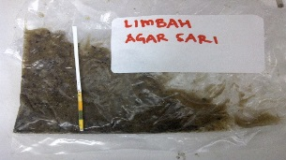
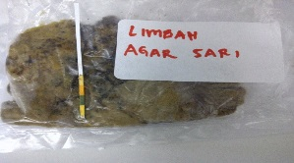

Figure 1. Industrial Seaweed Waste from PT. Agar Sari Malang

Growth Curve
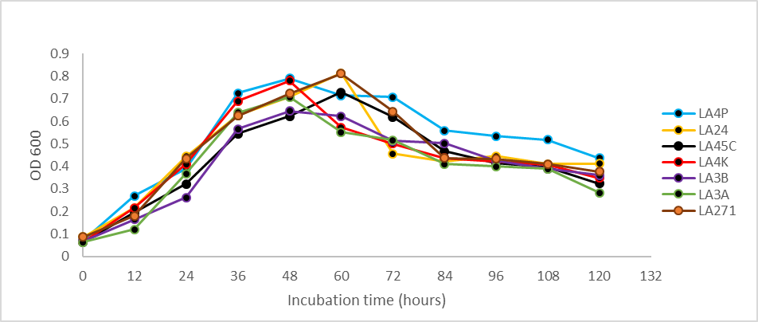
Figure 2. Time courses for cell growth of seven selected cellulolytic isolate in CMC culture broth

Based on the curve at figure 2, almost all seven selected isolate showed that incubation time at 36 hours was considered as the appropriate time to transfer the starter into production medium.

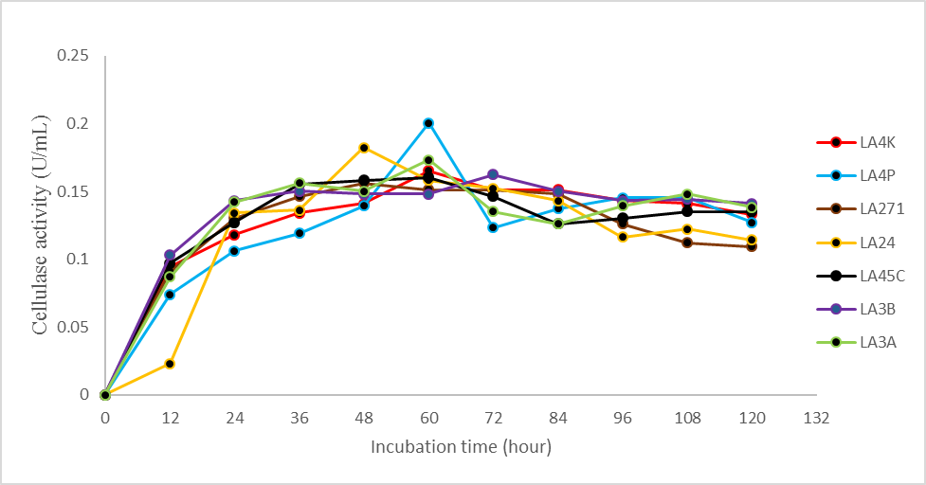
Figure 3. CMC degrading enzyme activity change of seven selected cellulolytic isolate in culture broth

Using CMC as substrate, Figure 3 showed that all tested isolates showed increased endoglucanase activity over the period of 60-72 hour. Among the isolates tested, LA4P isolates was estimated with maximum activity was 0.20 U/mL at 60 hours after incubation.

Tables 1. CMCase activity of seven selected isolate from solid waste
Isolates | Activity (U/mL) | Period of incubation (hours)
LA3B | 0.162237 | 72
LA24 | 0.182279 | 48
LA271 | 0.156225 | 48
LA45C | 0.160233 | 60
LA4K | 0.165244 | 60
LA4P | 0.200317 | 60
LA3A | 0.173260 | 60

DNA Extraction and PCR Amplification of 16S rRNA Bacterial Analysis

Bacterial isolates were grown in nutrient agar medium at 37⁰C for 48 hour. The culture were centrifuge at 12000 rpm for 5 minutes and the supernatant was removed. These seven strains selected of their best ability to degrade LIA media. Selected Cellulolytic bacterial isolates which have the potential cellulolytic were LA3, LA4K, L45C, LA4P, LA3B, LA271, and LA24. These isolates were amplified against the 16S rRNA gene targets with the size of the amplification products of approximately 1500 bp. Elektroferogram results of the amplification products are shown in figure 4 as follows :
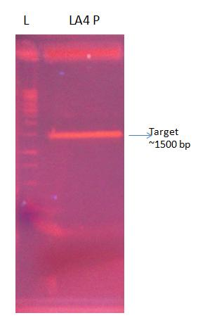
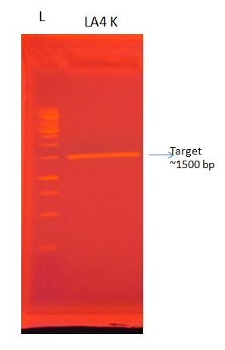
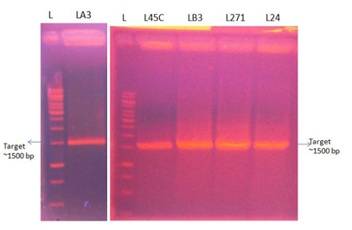
Figure 4. Gel electrophoresis DNA of selected isolate

The results of the purification shown in figure 2 samples LA3, LA4 K, LA4 P, L45C, LB3, L271, and L24 was performed with the sequencing process services company sequencing (Macrogen Inc., South Korea). Sequenced data then were further processed using Bioedit software. Further alignment was done with the database on www.ncbi.nlm.nih.gov/ and manufacture of phylogeny tree using http://www.phylogeny.fr/.

Results analysis of 16S rRNA fragment sequencing
- Isolate LA3

Based on the results of alignment with the database, the sample LA3 has similarities with bacteria from the Serratia marcescens group with identity value 99%. Phylogenetic tree of LA3 isolated reconctructed using reference sequence to serratia genus reference with the identity at least 90%. Outgroup used for phylogenetic tree reconstruction was Proteus mirabilis. Based on the calculation results from phylogram in figure 5, it can be seen that LA3 isolates have close relations with Serratia marcescens with similiarity value of 98.3%.
Here is phylogram result constructed by bootstrapping to 100 times :
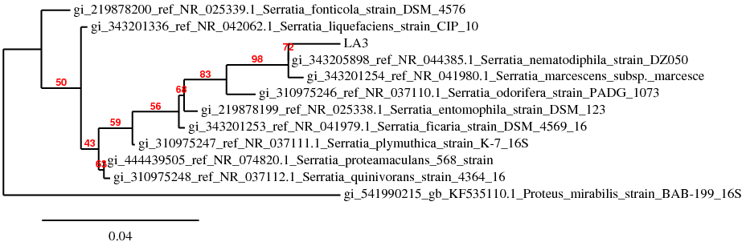

Figure 5. Phylogenetic tree based on 16S rRNA gene sequence of bacterial isolate LA3. The tree was constructed using sequences of comparable region of the 16S rRNA gene sequences available in public databases. Neighbour-joining analysis using 100 bootstrap replicates was used to infer tree topology. The scale bar shows the number of nucleotide substitutions per site of 4%.

Araujo et al. (2010) and Chan et al. (2013) revealed the ability of Serratia marcescens as biodegradation agent. Serratia marcescens UCP/WFCC 1549 produced biosurfactant using waste as alternative substrate what allows a reduction of fermentation and costs of the process (Chan et al., 2013).
A suitable strain for bioremediation of soils contaminated with OPPs identified as Serratia marcescens have ability of diazinon-degrading to remove organophosphorus pesticides (OPPs) as chlorpyrifos (CP), fenitrothion (FT), and parathion (PT) in sandy, sandy loam and silty soils (Cycon et al., 2013). Araujo et al. (2010) also has studied that Serratia marcescens presents in effluents from the process of iron ore flotation as the microorganisms responsible for fatty amine degradation.

- Isolate LA4K

Based on the alignment results with the database, LA4K isolates has similiarity with bacteria from the group Chryseobacterium indologenes with 96% identity value. Furthermore, phylogenetic tree reconstruction was performed using sequence references from the genus Chryseobacterium with minimal identity value at least 90%. Outgroup bacteria used for phylogenetic tree reconstruction was Leeuwenhoekiella marinoflava. Here is phylogram result constructed by bootstrapping to 100 times.
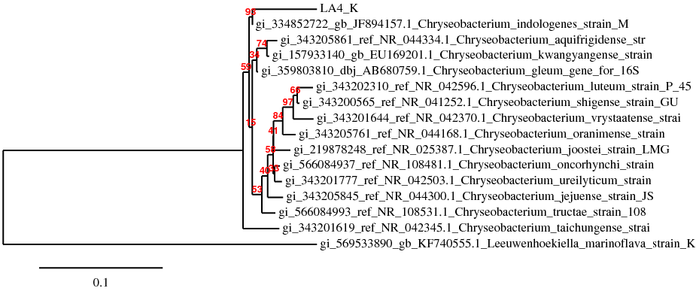

Figure 6. Phylogenetic tree based on 16S rRNA gene sequence of bacterial isolate LA4K. The tree was constructed using sequences of comparable region of the 16S rRNA gene sequences available in public databases. Neighbour-joining analysis using 100 bootstrap replicates was used to infer tree topology. The scale bar shows the number of nucleotide substitutions per site of 10%.

Based on the calculation results from phylogram above, it can be seen that LA4K isolates have close relations with Chryseobacterium indologenes with similiarity value of 94.8%. LA4K isolates is a non-motile, gram negative bacillus, catalase and oxidase positive, indole positive, non-fermentative, yellow pigmented bacteria. The 16S rRNA gene sequence analysis of strain LA4K indicated that Chryseobacterium indologenes is the closest related species with apair wise sequence similiarity of 94.8%.
Some literature stated that member Chryseobacterium were found in rhizosphere (Cho et al., 2010), water (Kumar et al., 2011), soil (Li & Zhu, 2012), fish (Zamora et al., 2012 a, b,c; Boran et al., 2013), mid gut of insect (Kampfer et al., 2010), clinical samples (Buresova et al., 2009; Calderon et al., 2011; Chang et al., 2014).
Previous studied revealed that Chryseobacterium indologenes is keratinase producer (Wang et al 2008), important bacterial group associated with plants in rhizosphere soil (Venil et al., 2014; Anderson & Habiger 2012), and exhibit plant growth promoting activities (Montero-calasanz et al., 2013).

- Isolates LA4P

Based on the alignment results with the database, LA4P isolates has similiarity with bacteria from the group Bacillus pumilus with 99% identity value. Furthermore, phylogenetic tree reconstruction was performed using sequence references from the genus Bacillus with minimal identity value at least 90%. Outgroup bacteria used for phylogenetic tree reconstruction was Listeria monocytogenes. Here is phylogram result constructed by bootstrapping to 100 times.

Figure 7. Phylogenetic tree based on 16S rRNA gene sequence of bacterial isolate LA4P. The tree was constructed using sequences of comparable region of the 16S rRNA gene sequences available in public databases. Neighbour-joining analysis using 100 bootstrap replicates was used to infer tree topology. The scale bar shows the number of nucleotide substitutions per site of 6%.
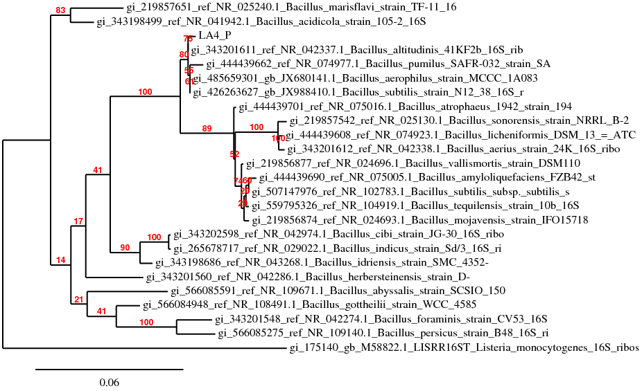

Based on the calculation results from phylogram above, it can be seen that LA4P isolates have close relations with Bacillus pumilus with similiarity value of 98.9%. LA4P isolates is a spore forming bacteria that is rod shape, gram positive, and aerobic. Bacillus species constitute a diverse group of bacteria widely distributed in soil and aquatic environment. Bacillus pumilus resides in soils and colonize in root plants have several bioactivity. Previous researcher reported the use of Bacillus pumilus in various industry as biocatalyst (Akbulut et al., 2013; Kuppers et al., 2014), biofuel (Edembe et al., 2012; Suraniti et al., 2013) and bioremedian (Watharkar et al., 2013).
The study by Watharkar et al., (2013) reveals the beneficial phytoremediation potential of Bacillus pumillus to degrade and to decolorize the dye Navy Blue RX to noteworthy level, released less toxic metabolites dye. Edembe et al. (2012) and Suraniti et al. (2013) studied the catalytic performance of bilirubin oxidase (BOD) from Bacillus pumilus showed high thermostability. The thermostable BOD reported was a promising alternative to the currently used BOD in biofuel cells and may open new perspectives for their use of biofuel cells in various bioelectronics applications.
Luz et al. (2010) and Ahmad et al. (2012) have reported that Bacillus pumilus has great potential for remediating soil contaminated with organic compounds such as pesticides residues in crop plants and enhancing plant growth in mine tailings.
To improve enzymatic activity of Bacillus pumilus lipases, DNA shuffling was applied to two lipase genes from local Bacillus pumilus isolates. That study showed that by DNA shuffling Bacillus pumilus lipase can improved applicability as biocatalyst (Akbulut et al., 2013).

- Isolates LA45C

Based on the alignment results with the database, LA45C isolates has similiarity with bacteria from the group Bacillus cereus with 96% identity value. Furthermore, phylogenetic tree reconstruction was performed using sequence references from the genus Bacillus with minimal identity value at least 90%. Outgroup bacteria used for phylogenetic tree reconstruction was Escherichia coli.

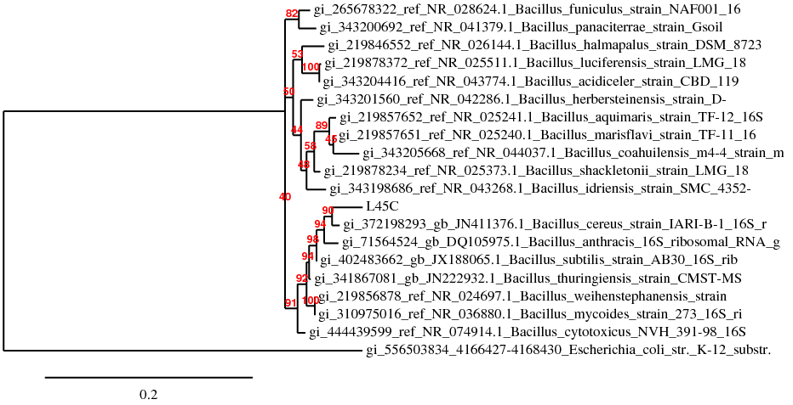
Figure 8. Phylogenetic tree based on 16S rRNA gene sequence of bacterial isolate LA45C. The tree was constructed using sequences of comparable region of the 16S rRNA gene sequences available in public databases. Neighbour-joining analysis using 100 bootstrap replicates was used to infer tree topology. The scale bar shows the number of nucleotide substitutions per site of 20%.

Based on the calculation results from phylogram above, it can be seen that LA45C isolates have close relations with Bacillus cereus with similarity value of 96.1%
The role of Bacillus cereus as bioremidiant agent has been reported by previous researcher (Gargouri et al., 2011; Sarma et al., 2014; Ghorbel-Bellaj et al., 2012; Huang et al., 2012; Sriram et al., 2011; Kadam et al 2012; Tripathi et al., 2014). Bioremediation processes, which take advantadge of microbial degradation of organic compounds, can be defined as the use of microorganisms (especially bacteria) to detoxify and remove pollutants from environment either from soils, waters and sediments (Gargouri et al., 2011).
Gargouri et al. (2011) was used Bacillus cereus to treat hydrocarbon-rich industrial wastewaters using a continuously stirred tank bioreactor. The treatment provided satisfactory results and presents a feasible technology for the treatment of hydrocarbon-rich industrial wastewaters from petrochemical industries and petroleum refineries.
Similar work was also done by Sarma et al. (2014), it was reported that crude oil contaminated soil is a good habitat for potent hydrocarbon degrader bacteria such as Bacillus aerus.

- Isolates LA3B

Based on the alignment results with the database, LA3B isolates has similiarity with bacteria from the group Stenotrophomonas maltophila with 97% identity value. Furthermore, phylogenetic tree reconstruction was performed using sequence references from the genus Bacillus with minimal identity value at least 90%. Outgroup bacteria used for phylogenetic tree reconstruction was Xylella fastidiosa. Here is phylogram result constructed by bootstrapping to 100 times.

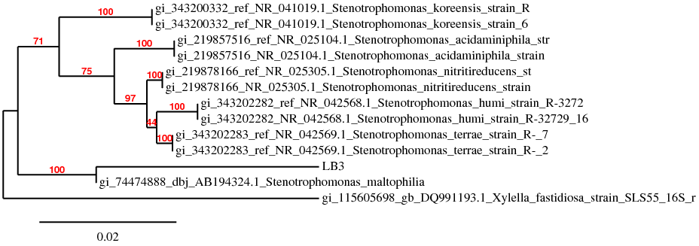

Figure 9. Phylogenetic tree based on 16S rRNA gene sequence of bacterial isolate LA3B. The tree was constructed using sequences of comparable region of the 16S rRNA gene sequences available in public databases. Neighbour-joining analysis using 100 bootstrap replicates was used to infer tree topology. The scale bar shows the number of nucleotide substitutions per site of 2%.

- Isolat LA24

Based on the alignment results with the database, LA24 isolates has similiarity with bacteria from the group Stenothrophomonas maltophila with 90% identity value. Furthermore, phylogenetic tree reconstruction was performed using sequence references from the genus Stenotrophomonas with minimal identity value at least 90%. Outgroup bacteria used for phylogenetic tree reconstruction was Shewanella morhuae. Here is phylogram result constructed by bootstrapping to 100 times.

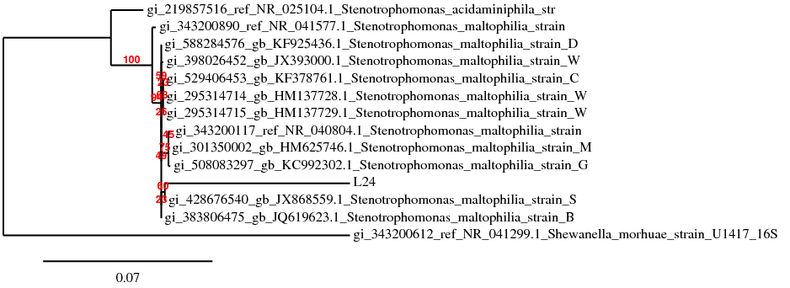

Figure 10. Phylogenetic tree based on 16S rRNA gene sequence of bacterial isolate LA24. The tree was constructed using sequences of comparable region of the 16S rRNA gene sequences available in public databases. Neighbour-joining analysis using 100 bootstrap replicates was used to infer tree topology. The scale bar shows the number of nucleotide substitutions per site of 7%.

Based on the calculation results from phylogram above, it can be seen that LA3B and LA27 isolates had the same result as Stenotrophomonas maltophila, with quite different the similiarity value. LA3B and LA24 isolates have close relations with Stenotrophomonas maltophila with similiarity value of 96.7% and 92.4%.
Stenotrophomonas maltophilia is an aerobic, non fermentative, gram negative bacterium. It is an uncommon bacterium and human infection is difficult to treat. Some studies have reported that Stenotrophomonas maltophila is a significant nosocomial pathogen, responsible for an increasing nimber of infections, particulary in immunocompromised patients (Garazi et al., 2012).
Some literature also mentions that Stenotrophomonas maltophila was applied in bioremediation processes to reduce the concentration and the toxicity of various pollutants, including petroleum products (Gargouri et al., 2011; Hassanshahian et al., 2013; Patel et al., 2013; Salek et al., 2013; Gao et al., 2014; Sarma et al., 2014).
Gargouri et al. (2011) revealed that the application of an aerobic Stenotrophomonas maltophilia CSTR (continuously stirred tank bioreactor) for the treatment of hydrocarbon-contaminated wastewater is an effective bioremediation technology. Hassanshahian et al. (2013) in his paper conclude that Stenotrophomonas maltophilia have ability to degrade hexadecane more diversity and ability for biodegradation in waste water petroleum reservoirs in Iran. Patel et al. (2013) studied that Strenotrophomonas malthophilia bacteria in a phenanthrene-degrading bacterial consortium (ASP) degraded phenanthrene in the presence of other pollutants, revealing that it efficiently utilized phenanthrene in the presence of a mixture of pollutants. Salek et al. (2013) reported that Stenotrophomonas maltophilia bacteria can use different substances for their growth including both diesel oil and polyglucosides.
Biosorption and biodegradation of triphenyltin by Stenotrophomonas maltophilia and their influence on cellular metabolism was studied by Gao et al., (2014). The results verified Stenotrophomonas maltophilia can effectively adsorb and degrade triphenyltin. Triphenyltin (TPT) was initially adsorbed by the cell surface of Stenotrophomonas maltophilia and was subsequently trans-ported and degraded intracellularly with diphenyltin and monophenyltin production.

- Isolat LA271

Based on the alignment results with the database, LA271 isolates has similiarity with bacteria from the group Pseudomonas aeruginosa with 93% identity value. Furthermore, phylogenetic tree reconstruction was performed using sequence references from the genus Pseudomonas with minimal identity value at least 90%. Outgroup bacteria used for phylogenetic tree reconstruction was Shewanella morhuae. Here is phylogram result constructed by bootstrapping to 100 times.

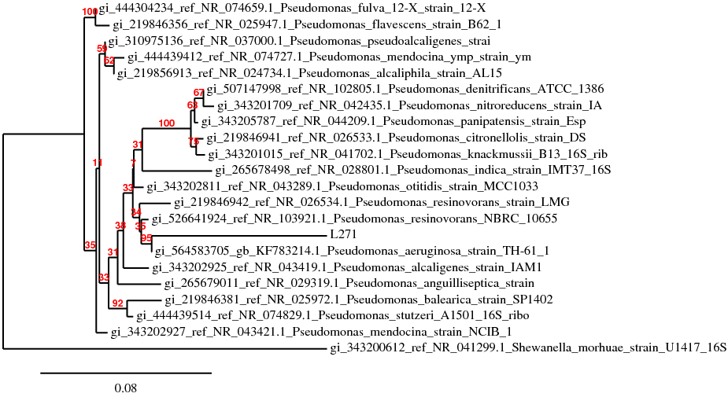

Figure 11. Phylogenetic tree based on 16S rRNA gene sequence of bacterial isolate LA271. The tree was constructed using sequences of comparable region of the 16S rRNA gene sequences available in public databases. Neighbour-joining analysis using 100 bootstrap replicates was used to infer tree topology. The scale bar shows the number of nucleotide substitutions per site of 8%.

Based on the calculation results from phylogram above, it can be seen that LA271 isolates have close relations with Pseudomonas aeruginosa with similiarity value of 91.6%. Pseudomonas spp. is a nonpathogenic soil bacterium, it produces greenish fluorescent pigment. The role of Pseudomonas spp.bacteria in the biodegradation, plant growth promoting activities, and detoxification of the toxicants is well documented (Wasi et al., 2013; Souza et al., 2014; Paraneeiswaran et al., 2014; Islam et al., 2014). Various Pseudomonas spp. strains have been reported to have potential biosurfactant activity and detoxification certain organic and inorganic water pollutants (Souza et al., 2014). A promising bioremediation approach was developed to remove [Co(III)-EDTA]_ complex that is generated during the waste management process by a halophilic solar-salt-pan isolate Pseudomonas aeruginosa SPB-1 (Paraneeiswaran et al., 2014). Sarma et al. (2014) stated that Pseudomonas spp. has ability as bioremediant of crude oil contaminated soil. It concluded that it was an effective process to clean petroleum contaminant from the environment. Islam et al. (2014) conclude that P.aeruginosa is an ideal candidate for bioremediation and wheat growth promotion against Zn-induced oxidative stress by improving the availability of necessary nutrient,eliciting antioxidant defense system as well as by lowering the Zn metal uptake. Zinc resistant isolates Pseudomonas aeruginosa showed multiple plant growth promoting activities, when this bacterium was inoculated under Zn stress, it significantly increased root and shoot length as well as the total dry weight of plants (Islam et al., 2014).

Tabel 2. Analysis of sequencing result selected isolate from solid waste of seaweed processing agar.

Code of isolates :  Taxon assignment | Size of colony (µm) | oksidase (oxoid sigma | Sequensing 16s rRNA result analysis
Code of isolates :  Taxon assignment | Size of colony (µm) | oksidase (oxoid sigma | % similiarity | Cellulolytic index
LA3A : Serratia marcescens | 26.4 | ++ | 99 | 2.75
LA4K : Chryseobacterium indologenes | 2.65 | ++ | 96 | 2.57
LA4P : Bacillus pumilus | 3.05 | ++ | 93 | 7
LA45C : Bacillus cereus | 57.90 | ++ | 96.1 | 0.4
LA3B: Strenatrophomonas maltophila | 20.71 | + | 97 | 3
LA271 : Pseudomonas aeruginosa | 36.96 | + | 93 | 4
LA24: Strenatrophomonas maltophila | 13.20 | ++ | 92 | 11.0

Sequencing and subsequent phylogenetic analysis of the 16S rRNA gene identified the isolates as Serratia marcescens, Chryseobacterium indovlogenes, Bacillus pumilus, Bacillus cereus, Strenatrophomonas maltophila, and Pseudomonas aeruginosa (Table 1).Cellulolytic bacteria species generally are found within the phyla Thermotogae, Proteobacteria, Actinobacteria, Spirochaetes, Firmicutes, Fibrobacteres and Bacteroids. Of these, approximately more than 80% of the isolated cellulolytic bacteria are found within phyla Firmicutes and Actinobacteria (Bergquist et al.,1999). Organisms that are capable of degrading the natural polymer and utilizing it as a source of carbon are ecologically very important. Cellulose is generally will be completely degraded into H₂O and CO₂ in aerobic systems while in anaerobic systems CH₄ and H₂ are also produced. Although, most cellulose is degraded by microbe in aerobic environments, 5 to 10% is degraded under anaerobic conditions by a range of physiologically diverse bacteria. Among these cellulolytic bacteria class Clostridia have been well studied and characterized. These bacteria are ubiquitous found in anaerobic soil environments, form endospores and digest cellulose via an exocellular enzymatic complex called a cellulosome, converting cellulose into several different metabolites. Thermotogae, Proteobacteria, Actinobacteria, Spirochaetesthe isolated cellulolytic bacteria are found within phyla Firmicutes and ActinobacterBergl.,1999).
CONCLUSION
In this research, we have isolated and identified cellulose producing bacteria solid waste of seaweed processing industry. The bacterial isolate was characterized based on 16S rRNA sequence and was identified as Serratia marcescens, Chryseobacterium indovlogenes, Bacillus pumilus, Bacillus cereus, Strenatrophomonas maltophila, and Pseudomonas aeruginosa. Those bacteria likely potential for biodegradation and biotechnological applications on the bioremediation of polluted environments.

REFERENCES
Ahmad, F., Iqbal, S., Anwar, S., Afzal, M., Islam, E., Mustafa, T., & Khan, Q. M. (2012). Enhanced remediation of chlorpyrifos from soil using ryegrass ( Lollium multiflorum ) and chlorpyrifos-degrading bacterium Bacillus pumilus C2A1. Journal of Hazardous Materials, 237-238, 110–115. doi:10.1016/j.jhazmat.2012.08.006
Akbulut, N., & Tuzlako, M. (2013). Improved activity and thermostability of Bacillus pumilus lipase by directed evolution ˙ s, 164, 123–129. doi:10.1016/j.jbiotec.2012.12.016
Anderson, M., Habiger, J. 2012. Characterization and identification of productivity assosiated rhizobacteria in wheat. Appl Environ Microbiol 78 4434-4446.
Araujo, D. M., Yoshida, M. I., Takahashi, J. A., Carvalho, C. F., & Stapelfeldt, F. (2010). International Biodeterioration & Biodegradation Biodegradation studies on fatty amines used for reverse fl otation of iron ore. International Biodeterioration & Biodegradation, 64(2), 151–155. doi:10.1016/j.ibiod.2010.01.004
Ariffin, H., Hassan, M., Shah, UK., Abdullah, N., Ghazali, FM., and Shirai Y. 2008. Production of bacterial endoglucanase from pretreated oil palm empty fruit bunch by Bacillus pumilus EB3. J. Biosci Bioeng 106:231-236.

Bergquist, P. L., Gibbs, M. D., Morris, D. D., Te’o, V. S. J., Saul, D. J., & Morgan, H. W. (1999). Molecular diversity of thermophilic cellulolytic and hemicellulolytic bacteria. FEMS Microbiology Ecology. doi:10.1016/S0168-6496(98)00078-6
Boran, H., Terzi, E., Altinok, I., Capkin, E., & Bascinar, N. (2013). Bacterial diseases of cultured Mediterranean horse mackerel ( Trachurus mediterraneus ) in sea cages. Aquaculture, 396-399, 8–13. doi:10.1016/j.aquaculture.2013.02.025
Buresova, V., Hajdusek, O., Franta, Z., Sojka, D., & Kopacek, P. (2009). IrAM — An α2-macroglobulin from the hard tick Ixodes ricinu s : Characterization and function in phagocytosis of a potential pathogen Chryseobacterium, 33, 489–498. doi:10.1016/j.dci.2008.09.011
Calderón, G., García, E., Rojas, P., García, E., Rosso, M., & Losada, A. 2011. Chryseobacterium indologenes infection in a newborn : a case report. Journal of Medical Case Reports, 5(1), 10. doi:10.1186/1752-1947-5-10
Chan, X. Y., Chang, C. Y., Hong, K. W., Tee, K. K., Yin, W. F., & Chan, K. G. 2013. Insights of biosurfactant producing Serratia marcescens strain W2 . 3 isolated from diseased tilapia fish : a draft genome analysis. Gut Pathogens, 5(1), 1. doi:10.1186/1757-4749-5-29
Chang, Y., Lo, H., & Hsieh, H. 2014.Identification , epidemiological relatedness , and biofilm formation of clinical Chryseobacterium indologenes isolates from central Taiwan. Journal of Microbiology, Immunology and Infection, (666), 1–6. doi:10.1016/j.jmii.2014.04.004
Cho, SH., Lee, KS., Shin, DS., Han, JH., Park, KS., Lee, CH., Park, KH., Kim, SB. 2010. Four new species of Chryseobacterium from the rizosphere of coastal sand dune plants, Chryseobacterium elyme sp. Nov., Chryseobacterium hagamense sp.nov., Chryseobacterium lathyri sp.nov. and Chryseobacterium rhizosphareae sp.nov. Syst Appl Microbiol 33, 122-127.
Cycon, M., Zmijowska, A., Wójcik, M., Seget, ZP. 2013. Biodegradation and bioremediation potential of diazinon-degrading Serratia marcescens to remove other organophosphorus pesticides from soils, 117. doi:10.1016/j.jenvman.2012.12.031
Edembe, L., Gounel, S., Cadet, M., Durand, F., & Mano, N. 2012. Electrochemistry Communications A highly efficient O₂ cathode cathode based on bilirubin oxidase from Bacillus pumilus operating in serum. Electrochemistry Communications, 23, 80–82. doi:10.1016/j.elecom.2012.07.013
Gao, J., Ye, J., Ma, J., Tang, L., & Huang, J. 2014. Biosorption and biodegradation of triphenyltin by Stenotrophomonas maltophilia and their influence on cellular metabolism. Journal of Hazardous Materials, 276, 112–119. doi:10.1016/j.jhazmat.2014.05.023
Garazi, M., Singer, C., Tai, J., & Ginocchio, C. C. 2012. Bloodstream infections caused by Stenotrophomonas maltophilia : a seven-year review. Journal of Hospital Infection, 81(2), 114–118. doi:10.1016/j.jhin.2012.02.008
Gargouri, B., Karray, F., Mhiri, N., Aloui, F., & Sayadi, S. 2011. Application of a continuously stirred tank bioreactor (CSTR) for bioremediation of hydrocarbon-rich industrial wastewater effluents. Journal of Hazardous Materials, 189 (1-2), 427–434. doi:10.1016/j.jhazmat.2011.02.057
Ghorbel-bellaaj, O., Manni, L., & Jellouli, K. 2012. Optimization of protease and chitinase production by Bacillus cereus SV1 on shrimp shell waste using statistical experimental design . Biochemical and molecular characterization of the chitinase, 1255–1268. doi:10.1007/s13213-011-0371-x
Hassanshahian, M., Ahmadinejad, M., Tebyanian, H., Kariminik, A. 2013. Isolation and characterization of alkane degrading bacteria from petroleum reservoir waste water in Iran (Kerman and Tehran provenances). Marine Pollution Bulletin 73 pp. 300–305. http://dx.doi.org/10.1016/j.marpolbul.2013.05.002
Hasunuma, T., Okazaki, F., Okai, N., Hara, K. Y., Ishii, J., & Kondo, A. (2013). A review of enzymes and microbes for lignocellulosic biorefinery and the possibility of their application to consolidated bioprocessing technology. Bioresource Technology, 135, 513–522. doi:10.1016/j.biortech.2012.10.047
Huang, F., Guo, Chu-Ling., Lu, Gui-Ning., Yi Xiao-Yun., Zhu, Lian-Dong., Dang, Zhi. 2014. Biaccumulation characterization of cadmium by growing Bacillus cereus RC-1 and its mechanism. Chemosphere vol.109 pp 134-142. doi : 10.1016/j.chemosphere.2014.01.066
Huang, S., Sheng, P., & Zhang, H. 2012. Isolation and Identification of Cellulolytic Bacteria from the Gut of Holotrichia parallela Larvae (Coleoptera: Scarabaeidae). International Journal of Molecular Sciences. doi:10.3390/ijms13032563
Islam, F., Yasmeen, T., Ali, Q., Ali, S., Saleem, M., Hussain, S., & Rizvi, H. 2014. Ecotoxicology and Environmental Safety In fl uence of Pseudomonas aeruginosa as PGPR on oxidative stress tolerance in wheat under Zn stress. Ecotoxicology and Environmental Safety, 104, 285–293. doi:10.1016/j.ecoenv.2014.03.008
Jung, H. R., & Krause, K. 2014. Cellulase activity screening using pure carboxymethylcellulose: Application to soluble cellulolytic samples and to plant tissue prints. International Journal of Molecular Sciences, 15(1), 830–838. doi:10.3390/ijms15010830
Jung, K. A., Lim, S., Kim, Y., & Moon, J. 2013. Bioresource Technology Potentials of macroalgae as feedstocks for biorefinery. Bioresource Technology, 135, 182–190. doi:10.1016/j.biortech.2012.10.025
Kadam, A. A., & Kamatkar, J. D. 2012. Solid-state fermentation : tool for bioremediation of adsorbed textile dyestuff on distillery industry waste-yeast biomass using isolated Bacillus cereus strain EBT1. doi:10.1007/s11356-012-0929-6
Kampfer, P., Arun, A.B., Young, CC., Chen, WM., Sridhar, KR., Rekha, PD. 2010. Chryseobacterium arthrospaerae sp.nov., isolated from the faeces of the pill millipede Arthrospaera magna. Int J Syst Evol Microbiol 60, 1765-1769.
Kumar, PA., Srinivas, TNR., Prasad, AR., Shivaji, S. 2011. Identification of Fruity Aroma Producing Compounds from Chryseobacterium.sp Isolated from the Western Ghats, India. Journal Current Microbiology volume 63 issue 2 pp 193-197. Springer-Verlag. DOI 10.1007/s00284-011-9966-5.
Kumar, S., Gupta, R., Kumar, G., Sahoo, D., & Kuhad, R. C. 2013. Bioethanol production from Gracilaria verrucosa, a red alga, in a biorefinery approach. Bioresource Technology, 135, 150–156. doi:10.1016/j.biortech.2012.10.120
Küppers, T., Steffen, V., Hellmuth, H., Connell, T. O., Bongaerts, J., Maurer, K., & Wiechert, W. 2014. Developing a new production host from a blueprint : Bacillus pumilus as an industrial enzyme producer, 1–11. doi:10.1186/1475-2859-13-46
Luz, E., Hernandez, J., Bashan, Y., & Maier, R. M. 2010. Bacillus pumilus ES4 : Candidate plant growth-promoting bacterium to enhance establishment of plants in mine tailings 69, 343–352. doi:10.1016/j.envexpbot.2010.04.014
Lynd, L. R., Weimer, P. J., Zyl, W. H. Van, & Isak, S. 2002. Microbial Cellulose Utilization : Fundamentals and Biotechnology Microbial Cellulose Utilization : Fundamentals and Biotechnology, 66(3). doi:10.1128/MMBR.66.3.506
Montero-calasanz, M. C., Go, M., Rohde, M., Schumann, P., Schmid, M., Tindall, B. J., & Klenk, H. (2013). Chryseobacterium hispalense sp.nov., a plant- growth-promoting bacterium isolated from a rainwater pond in an olive plant nursery , and emended descriptions of Chryseobacterium defluvii, Chryseobacterium indologenes, Chryseobacterium wanjuense and Chryseobacterium gregarium, 4386–4395. doi:10.1099/ijs.0.052456-0
P2HP. 2012. Industri Pengolahan Rumput Laut Nasional, Direktur Jendral Pengolahan dan Pemasaran Hasil Pengolahan Kementerian Kelautan dan Perikanan.

Paraneeiswaran, A., Shukla, S. K., Rao, T. S., & Prashanth, K. 2014. Chemosphere Removal of toxic Co-EDTA complex by a halophilic solar-salt-pan isolate Pseudomonas aeruginosa SPB-1. Chemosphere, 95, 503–510. doi:10.1016/j.chemosphere.2013.09.107
Patel, V., Patel, J., & Madamwar, D. (2013). Biodegradation of phenanthrene in bioaugmented microcosm by consortium ASP developed from coastal sediment of Alang-Sosiya ship breaking yard. Marine Pollution Bulletin, 74(1), 199–207. doi:10.1016/j.marpolbul.2013.07.001
S, M. V. Del. (2012). Biotechnology for Biofuels Biotechnology for Biofuels. doi:10.1186/1754-6834-5-73
Sałek, K., Zgoła-grze, A., & Kaczorek, E. 2013. Colloids and Surfaces B : Biointerfaces Modification of surface and enzymatic properties of Achromobacter denitrificans and Stenotrophomonas maltophilia in association with diesel oil biodegradation enhanced with alkyl polyglucosides, 111, 36–42. doi:10.1016/j.colsurfb.2013.05.021
Sarma, A., Baruah, R., Borah, M., Kumar, A., Prasanna, H., Boruah, D., Bora, T. C. 2014. International Biodeterioration & Biodegradation Bioremediation potential of native hydrocarbon degrading bacterial strains in crude oil contaminated soil under microcosm study. International Biodeterioration & Biodegradation, 94, 79–89. doi:10.1016/j.ibiod.2014.03.024
Souza, E. C., Vessoni-penna, T. C., Pinheiro, R., & Oliveira, D. S. 2014. International Biodeterioration & Biodegradation Biosurfactant-enhanced hydrocarbon bioremediation : An overview. International Biodeterioration & Biodegradation, 89, 88–94. doi:10.1016/j.ibiod.2014.01.007
Sriram, M. I., Kalishwaralal, K., Deepak, V., & Gracerosepat, R. (2015). Colloids and Surfaces B : Biointerfaces Biofilm inhibition and antimicrobial action of lipopeptide biosurfactant produced by heavy metal tolerant strain Bacillus cereus NK1, 1–3. doi:10.1016/j.colsurfb.2011.02.026
Suraniti, E., Tsujimura, S., Durand, F., & Mano, N. (2013). Electrochemistry Communications Thermophilic biocathode with bilirubin oxidase from Bacillus pumilus. Electrochemistry Communications, 26, 41–44. doi:10.1016/j.elecom.2012.10.004
Tripathi, M., Garg, SK., 2014. Dechlorination of chloroorganics, decolorization, and simultaneous bioremediation of Cr6+ from real tannery effluent employinh indigenous Bacillus cereus isolate. Springer Berlin Heidelberg. Environ Sci Pollut Res Volume 21 (7) pp.5227-5241 doi:10.1007/s11Tr356-013-2479-y.
Venil, C. K., Nordin, N., Zakaria, Z. A., Ahmad, W. A., T, C. N., & T, C. L. M. G. (2014). Chryseobacterium artocarpi sp . nov ., isolated from the rhizosphere soil of Artocarpus integer Printed in Great Britain, (December 2012), 3153–3159. doi:10.1099/ijs.0.063594-0
Wang, SL., Hsu, WT., Liang, TW., Yen, YH., Wang, CL. 2008. Purification and characterization of three novel keratinolytic metalloproteases produced by Chryseobacterium indologenes TKU014 in a shrimp shell powder medium. Bioresource Technology Vol 99 issue 13 p.5679-5686 . doi:10.1016/j.biortech.2007.10.024
Wasi, S., Tabrez, S., & Ahmad M. 2013. Use of Pseudomonas spp. for the bioremediation of environmental pollutants: a review. Environ Monit Assess doi: 10.1007/s10661-013-3163-x.
Watharkar, DA., Rane, NR., Patil, SM., Khandare, RV., Jadhav, JP. 2013. Enhanced phytotransformation of Navy Blue RX dye by Petunia grandiflora Juss with augmentation of rhizospheric Bacillus pumilus strain PgJ and subsequent toxicity analysis. Bioresource Technology 142 p.246-254.

Zamora, L., Fernández-garayzábal, J. F., Palacios, M. A., & Sánchez-porro, C. (2012). Chryseobacterium oncorhynchi sp . nov ., isolated from rainbow trout (Oncorhynchus mykiss). Systematic and Applied Microbiology, 35(1), 24–29. doi:10.1016/j.syapm.2011.10.002

